Assignment for **Oracle E- Business Procurement/Purchasing**

Date:22nd Nov-2024

[Provide screenshots of each step (which performed in a live environment).   
As evidence all the activity screens shot needs to be attached].

3. Check one of the existing Supplier, check this Supplier eligible for the Followings or not.

**RFQ , Purchasing, Payment**

4. For The same above Supplier checks the Bank details & Payment Method.

5. Query one existing Requisition & check what are all information has been captured/update for the respective Requisition.

6. Query one existing PO & check what are all information has been captured/update for the respective PO.

7.Explain the key modules of Oracle EBS Procurement Suite.

10. What is the **PROCUREMENT/PURCHASING** key Configuration?   
Each of the setup component what are all Information in captured while configuring need to demonstrate.

11. Navigate Provide screenshots or descriptions of the following:

* The requisition.
* Purchase Order.
* Receipt for PO.

12. Your company requires the following items for a project:

* 5 Desktop Computers
* 10 Office Chairs

You are tasked to procure these items using Oracle Procurement.

Steps to Complete:

13. **Create a Supplier:**

* If the supplier doesn't exist, create a new supplier record, including address, contact information, and payment terms.

14. **Create a Requisition:**

15.**Create a New Purchase Order**: Standard with currency type as USD

Enter **Order Information**:

* **Supplier**: Select the supplier from the list of available suppliers.
* **Order Type**: Choose the appropriate order type (for example, **Standard**).

16. Create a Quotation for any of the existing supplier.

17. Verify all accounts which are updated for financial options.

3. Navigation: **Purchasing>Supply Base> Suppliers**

This will take you to the webpage with a list of all suppliers. I selected Agile Electronics, then clicked Generate Report.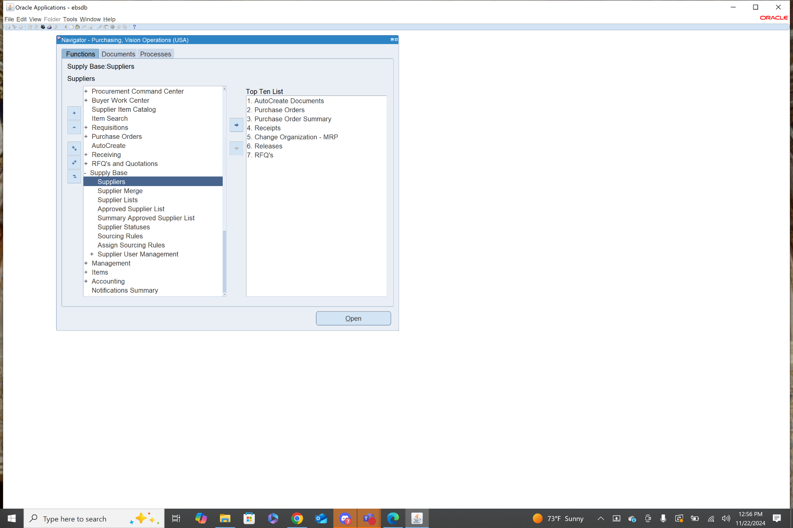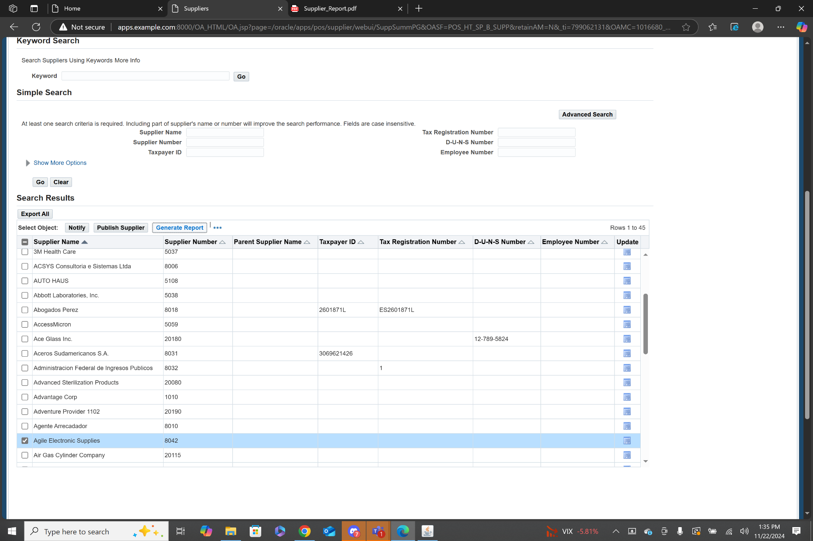

In this report I scrolled down to the Supplier Site Information section. In this section it shows Purchasing :Y, RFQ Only: N, Pay: Y. This means the Supplier is eligible for standard purchasing transactions, as well as RFQs. Purchasing and Pay are checked as Y so they are eligible for both of those.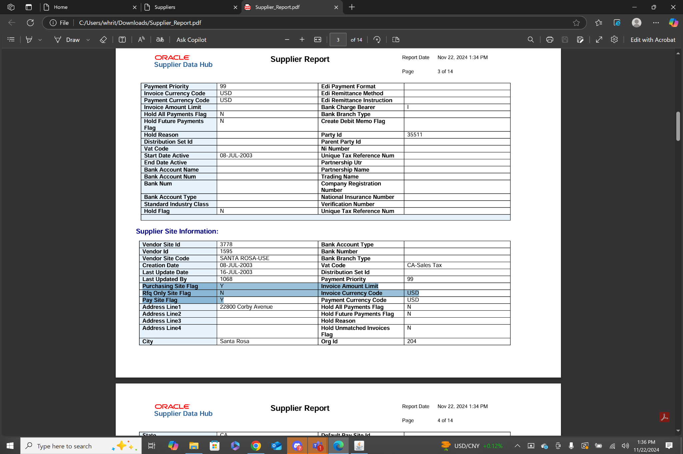

4.Using the same report generated in question 3, no bank details are given, but the payment method is declared as CHECK.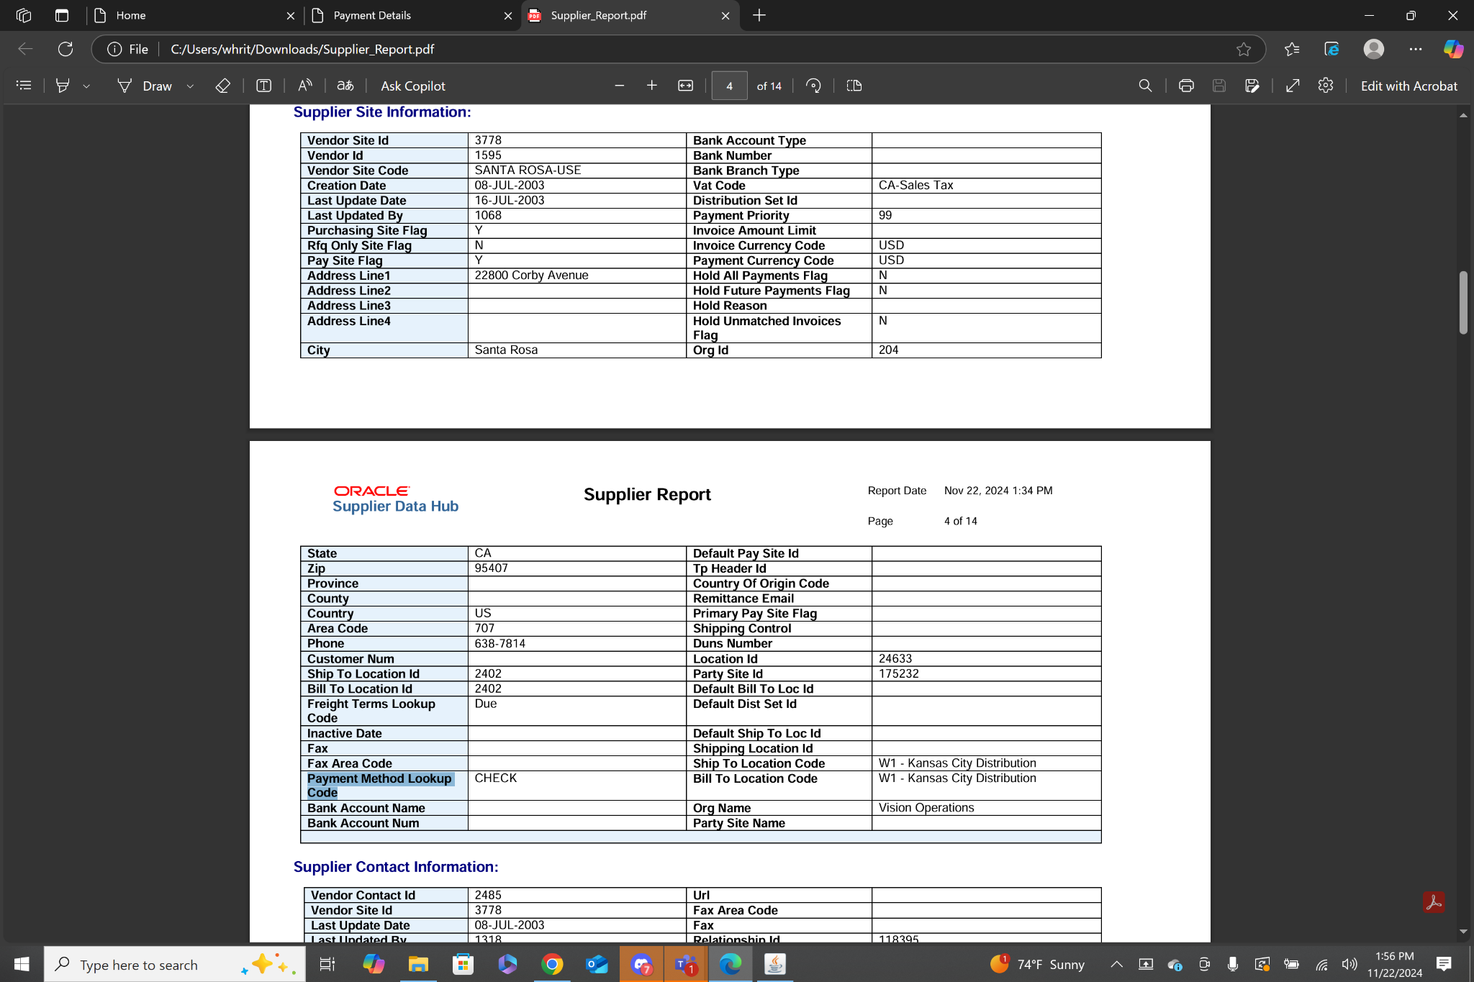

5. Navigation: **Purchasing>Requisitions>Requisition Summary**

This will bring you to a find Requisitions menu. Mine was prefilled with the operating unit Vision Operations. With that one criteria I then clicked the find button, which provides a list of all requisitions under Vision Operations.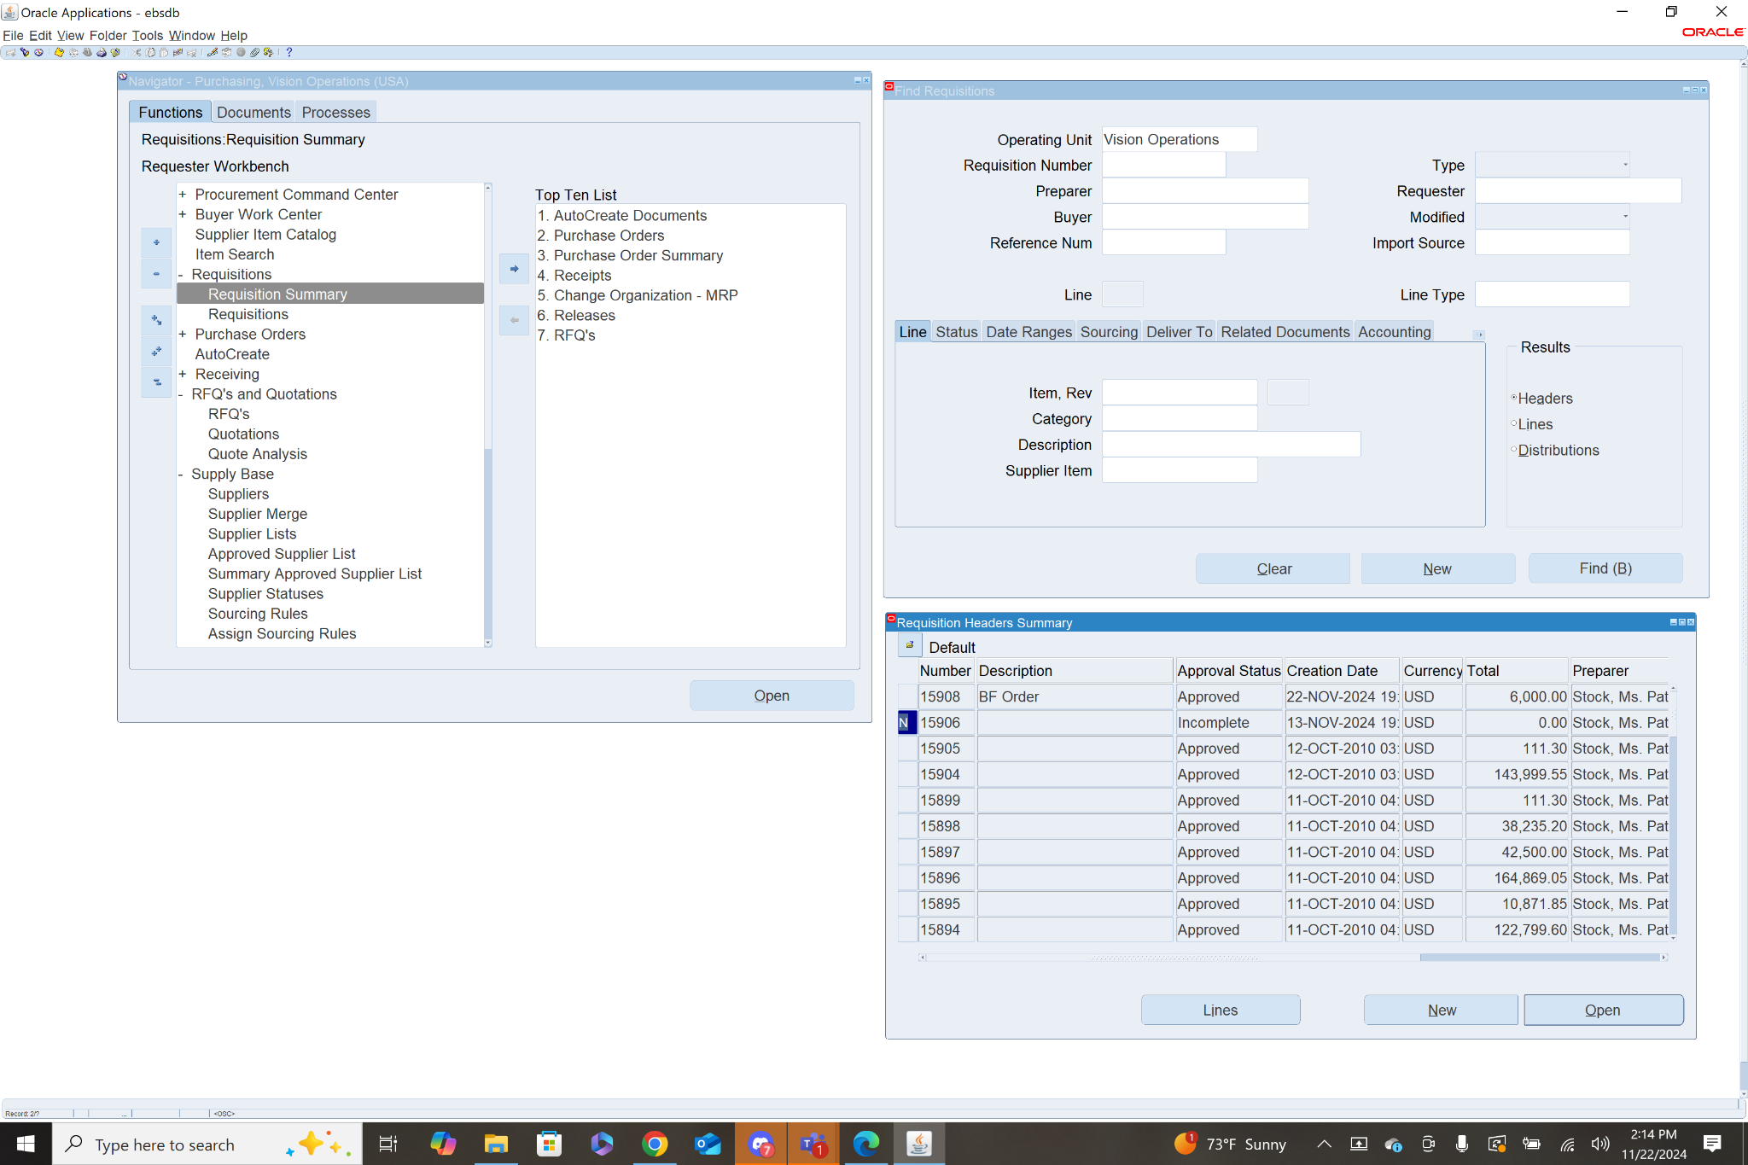I selected the number 15906 and clicked open. This opens a menu with the details of this requisition.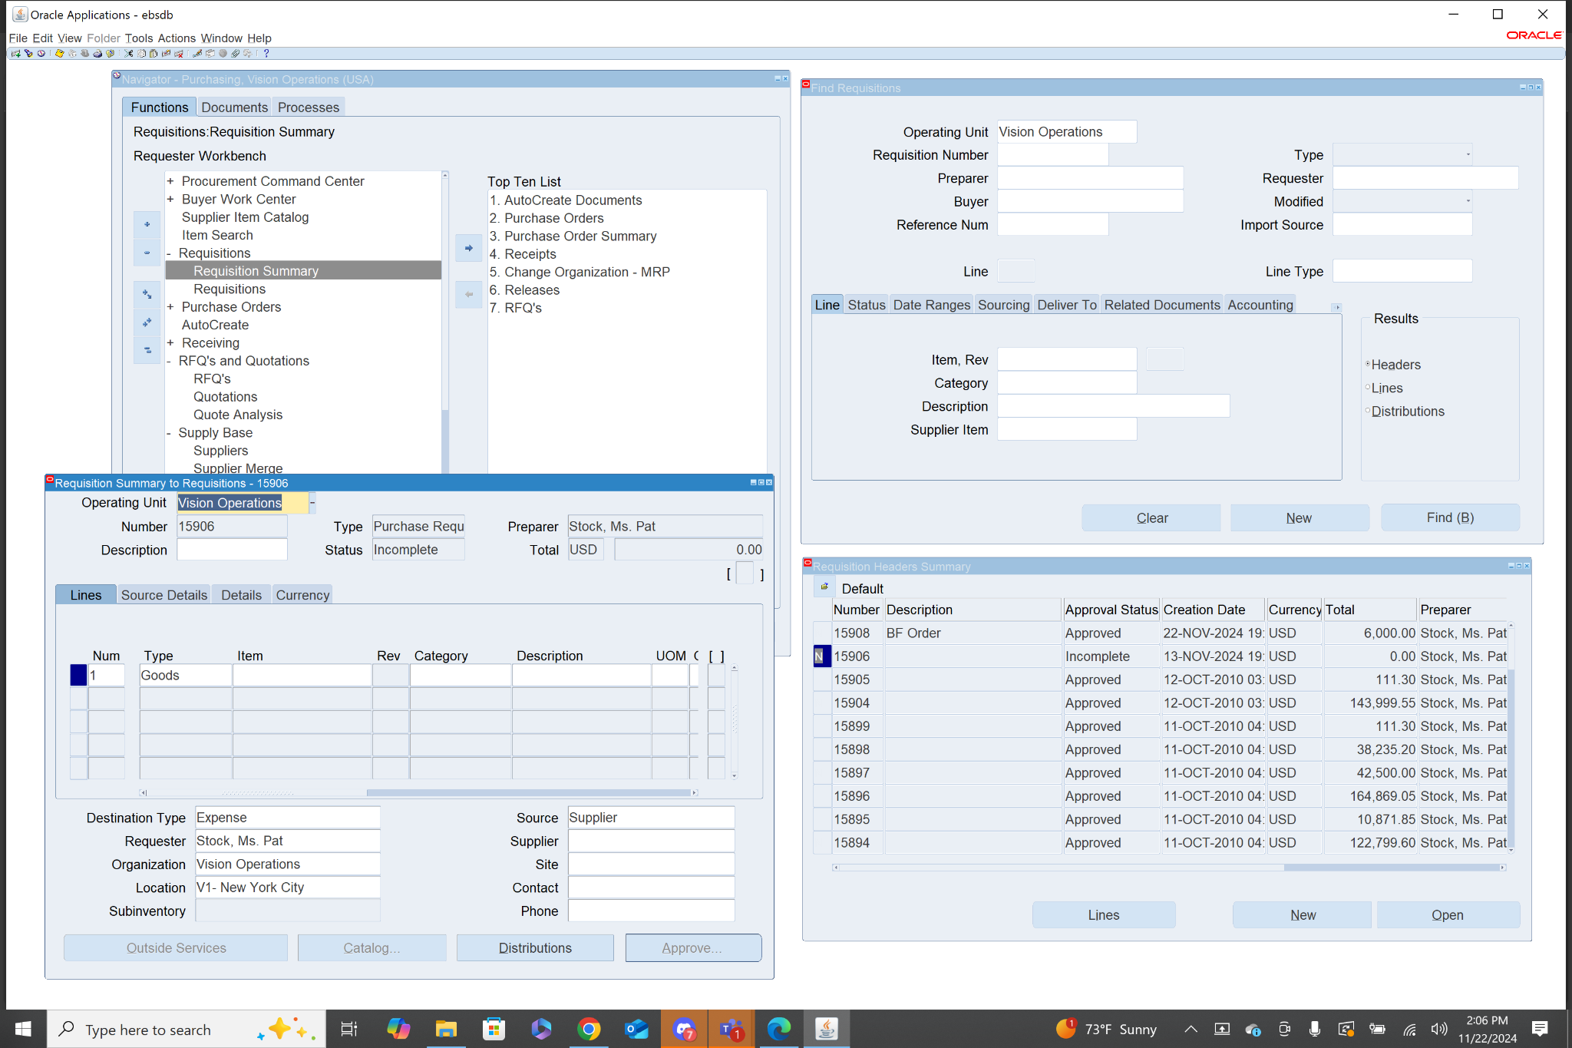

The information includes; Operating Unit, Number, Type, Preparer, Status, Total $ amount in USD, Line Items of the exact items involved in the transaction, Destination Type, Source, Requester, Organization,and Location.

6. Navigation: **Purchasing>Purchase Orders>Purchase Order Summary**

This will bring you to the find Purchase Orders menu. Mine was prefilled with the operating unit Vision Operations. With that one criteria I then clicked the find button, which provides a list of all purchase orders under Vision Operations.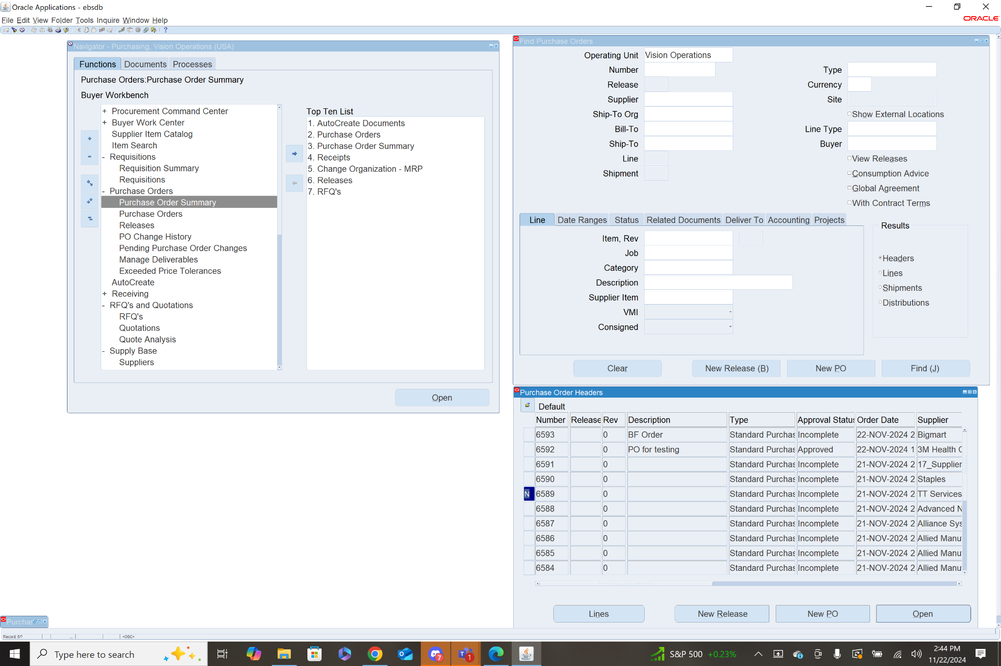

I selected number 6589 and clicked open, which brought up a menu with that order’s information.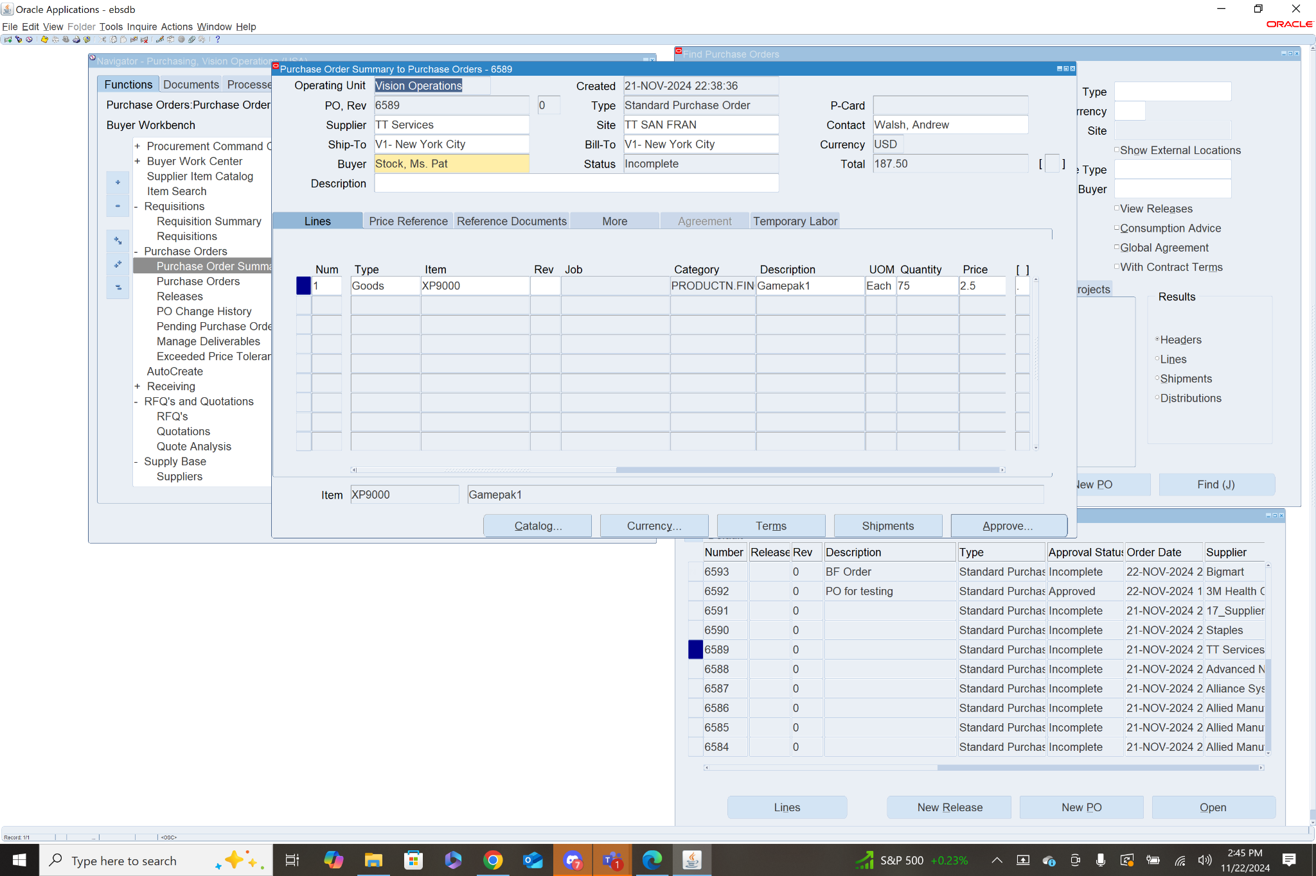

The information includes; Operating Unit, Created Date, PO Rev, Type, Supplier, Site, Contact, Ship-to, Bill-to, Currency, Buyer, Status, Total $ amount in USD, there is also a lines list indicating the specific items to be purchased with details for each item.

7. A List of Key Oracle Procurement Suite Modules:

* Suppliers
  + The suppliers module allows a business to organize a list of all the suppliers they use or may use in the future. This creates a database for a business that not only includes the names of their suppliers but all vital information, including: location, payment details, and products to name a few.
* RFQs
  + RFQs allow a business to send out requests to their suppliers for quotations on a specific item or list of items. This enables the business to be able to check the prices of various suppliers, so that they can make the best decision with the most information.
* Requisition
  + Once all the RFQs have been processed a requisition is made as a precursor to a purchase order. This step essentially is a request for the manager to verify information and approve that a purchase order can be created for the given items in the requisition.
* Purchase Orders
  + After approval an official purchase order can be created for the approved items from the approved supplier. This notifies the supplier that the business wants to purchase an item or items at a certain quantity.
* Receiving
  + This step creates receipts for items that have been received from purchase orders. At this stage the items received will also need to be checked for correct quantity as well as a quality inspection if necessary.
* Invoice and Payment
  + This step is under the Accounts Payable but is important, otherwise your suppliers would not be happy. At this stage you will match invoices with Purchase Orders and Receipts, ensuring that everything lines up with what is expected. Then given it is all correct you can approve and pay invoices.

10. Components of Purchasing Key Configurations

* Financial Options- **Purchasing>Setup>Organizations>Financial Options**
  + Defines financial and default accounting settings
  + Information
    - Accounts
    - Encumbrance Settings
    - Tax Information

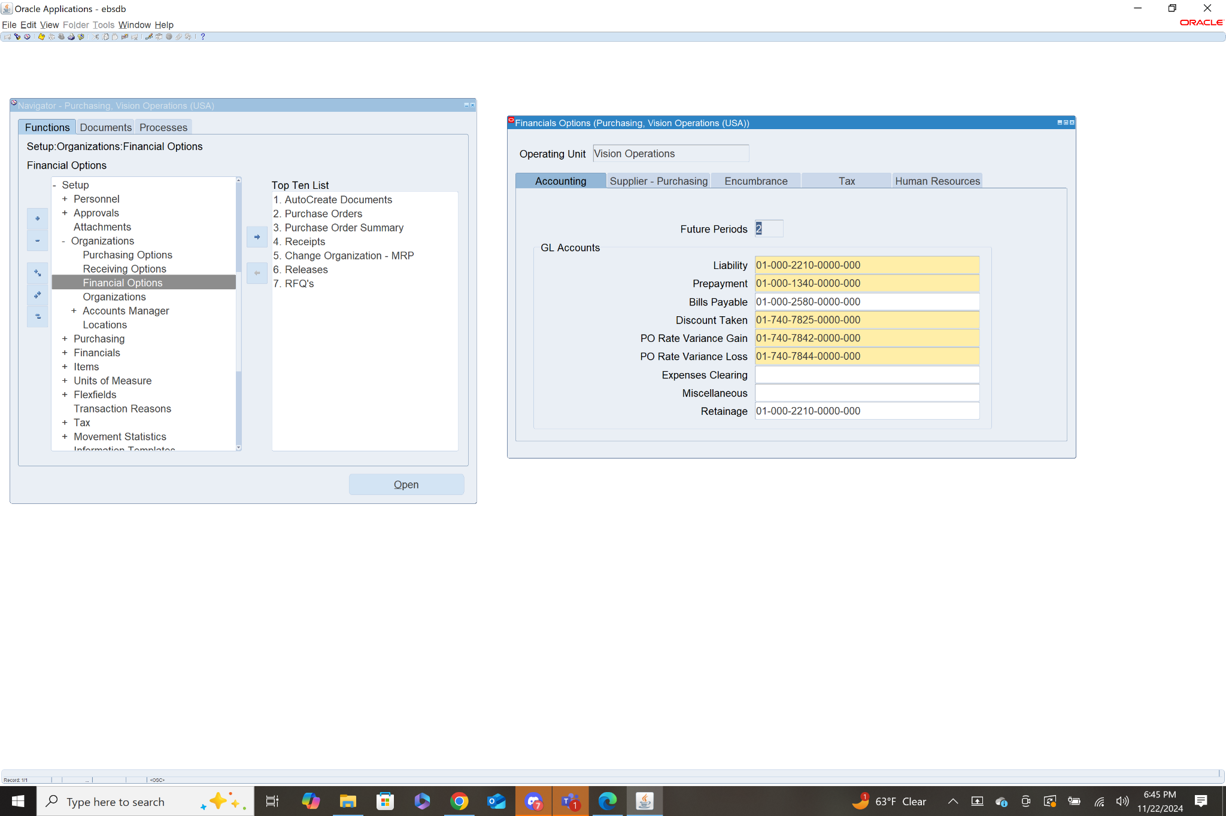

* Purchasing Options- **Purchasing>Setup>Organizations>Purchasing Options**
  + Sets organization level purchasing defaults and controls
  + Information
    - Document Controls
    - Receiving Controls
    - Approval Controls
    - Supplier Defaults
    - Sourcing Rules

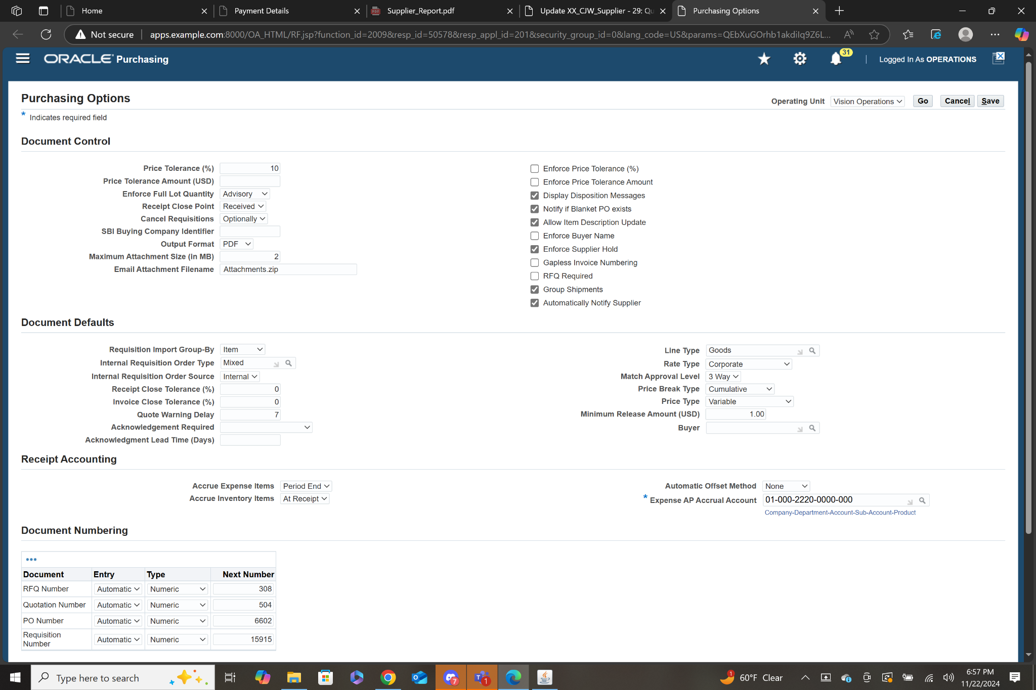

* Approval Hierarchy- **Purchasing>Setup>Approvals>Approval Assignments/Groups**
  + Creates a structure for requisition and purchase order approvals
  + Information
    - Approval Groups
    - Approval Hierarchy
    - Assignments

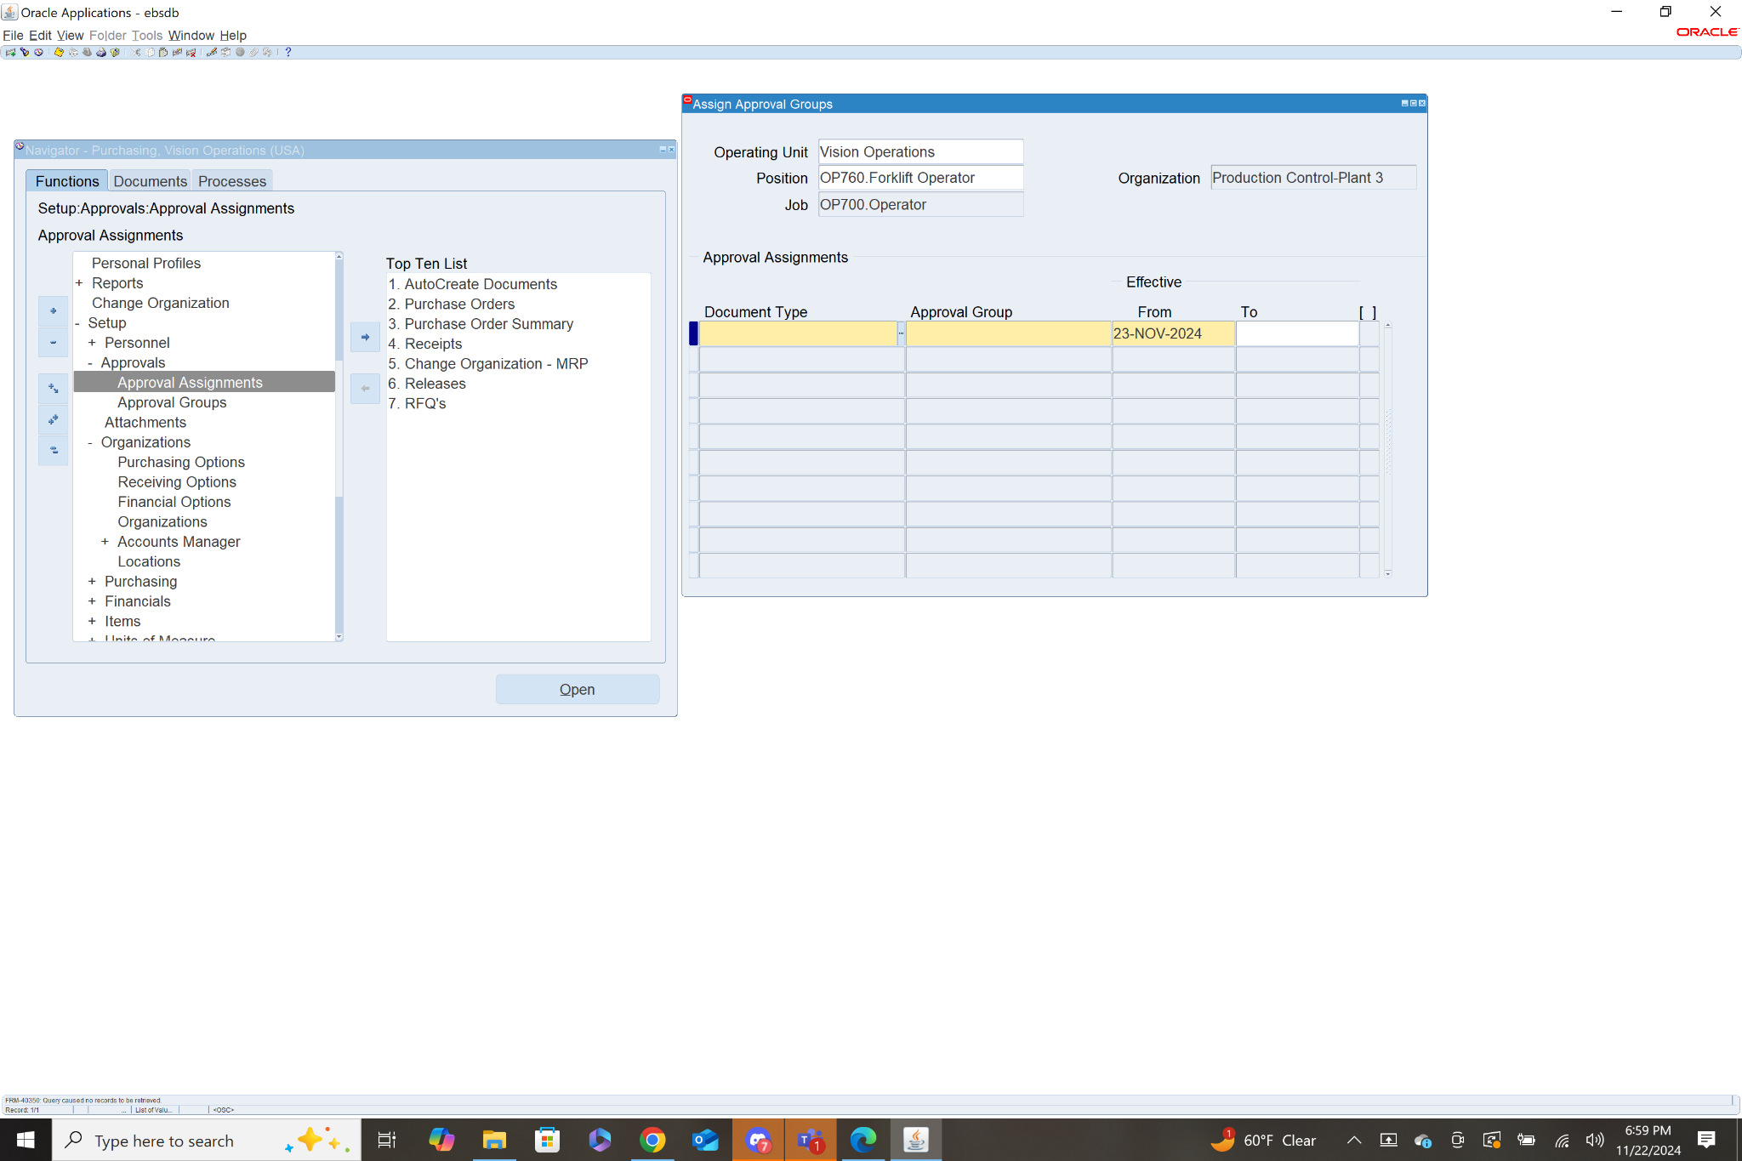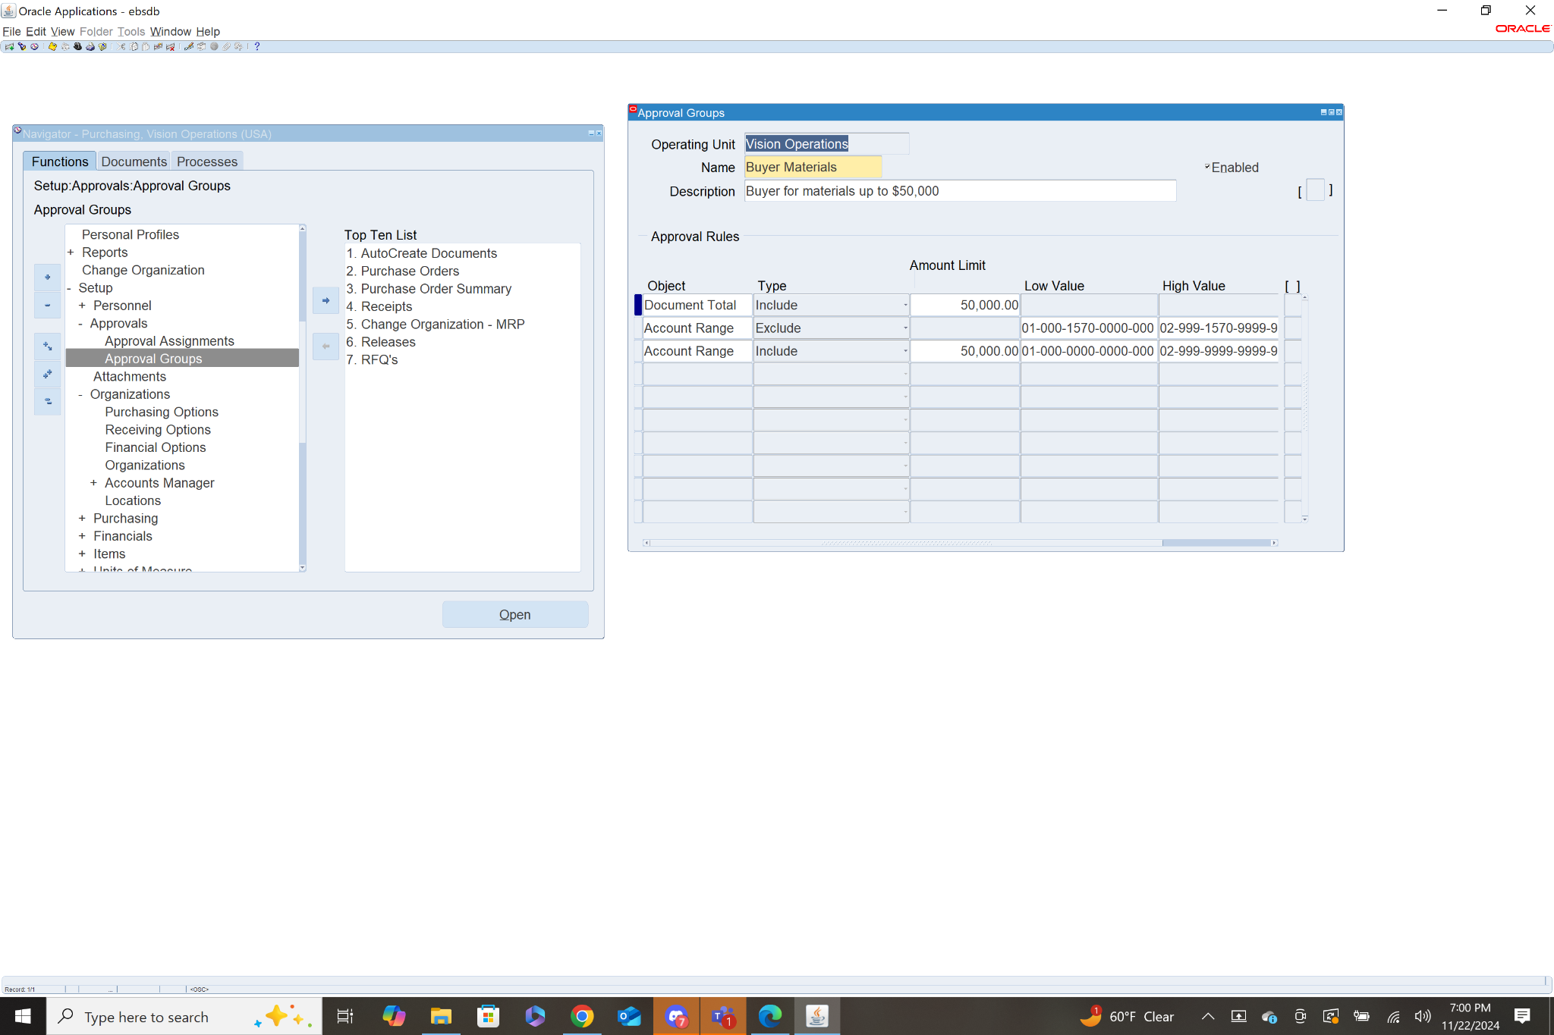

* Supplier Setup- **Purchasing>Supply Base> Suppliers**
  + Create and maintain suppliers for purchasing transactions
  + Information
    - Supplier Header
    - Supplier Sites
    - Banking Data
    - Contact Info

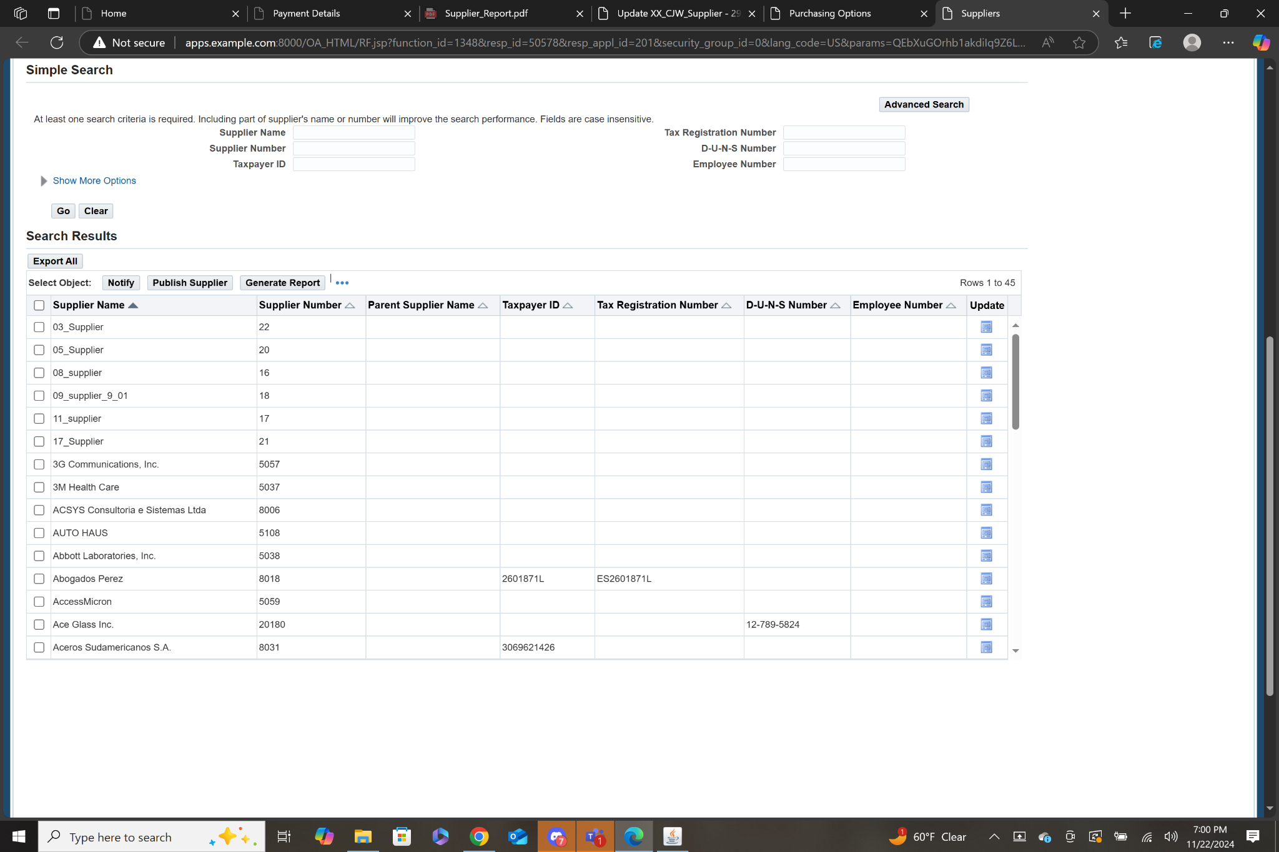

* Define Items- **Purchasing>Items>Master Items**
  + Create items for procurement and ensure categorization
  + Information
    - Item Data
    - Purchasing Data
    - Inventory Data
    - Cost Data

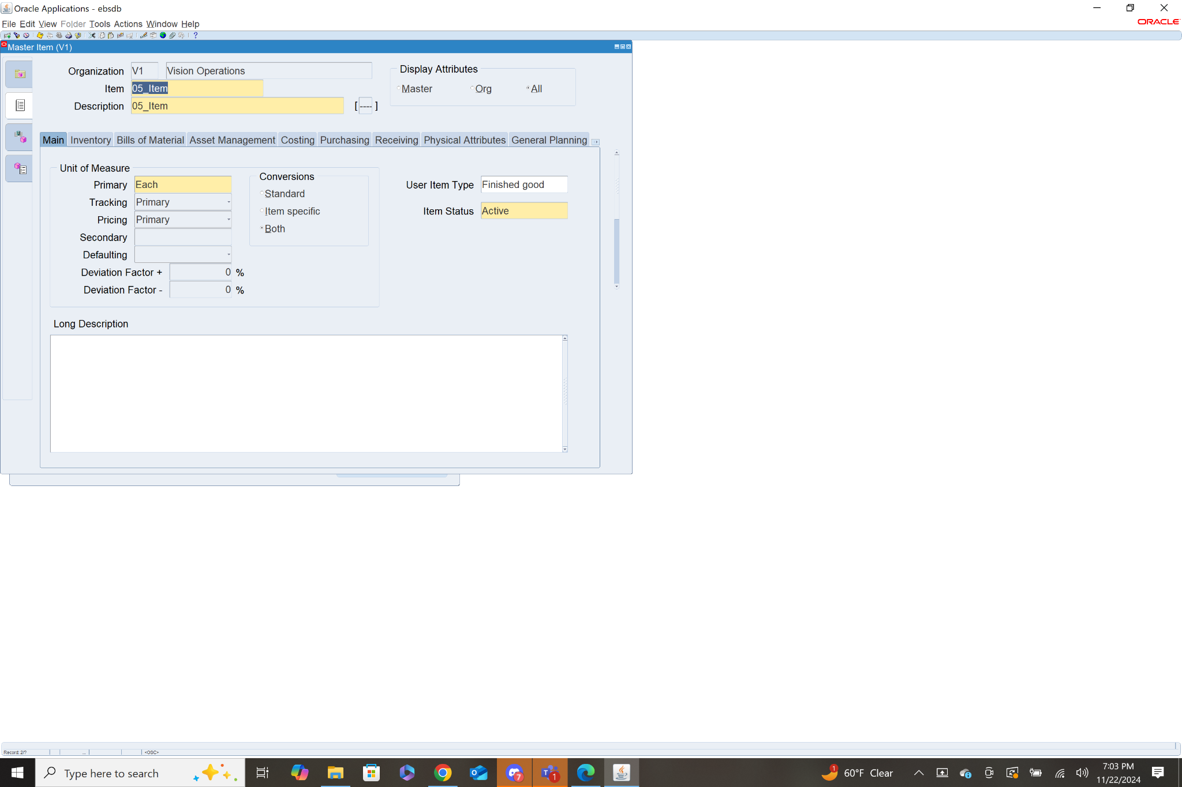

* Receiving Items- **Purchasing>Setup>Organizations>Receiving Options**
  + Define how goods and services are received
  + Information
    - Receipts
    - Receipt Tolerances
    - Delivery Settings

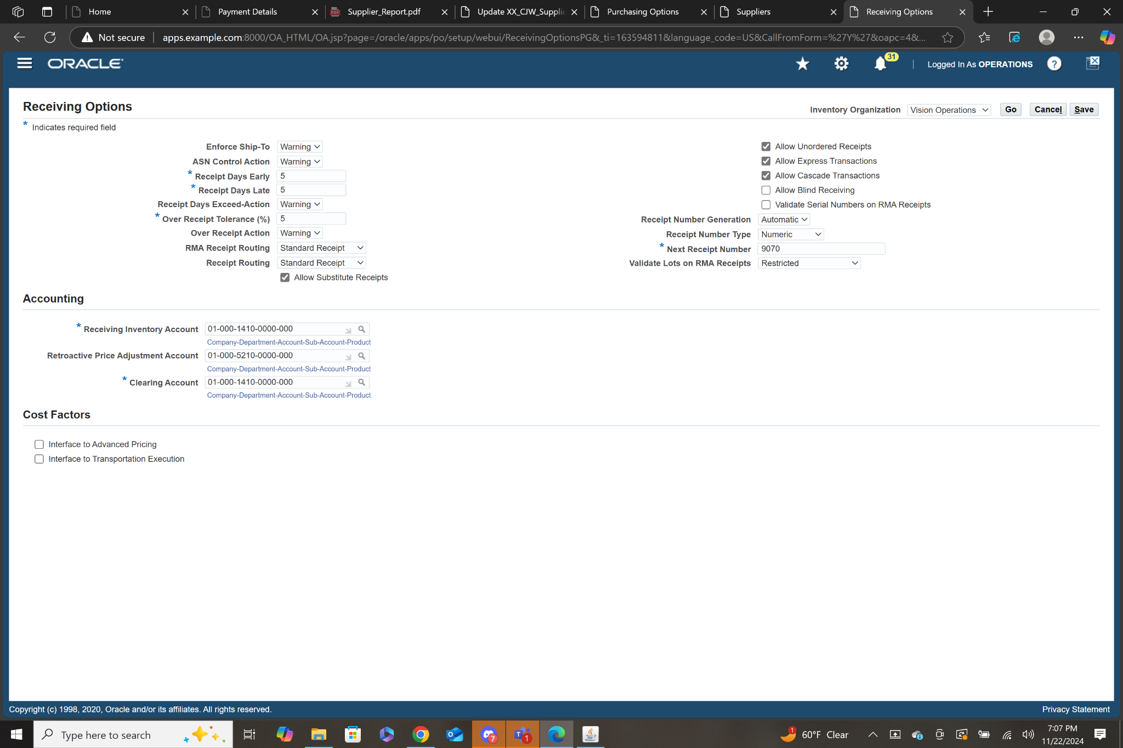

* Invoice Matching and Tolerances-
  + Setup matching and tolerance settings for invoice validation
  + Information
    - Matching Rules
    - Tolerance Levels

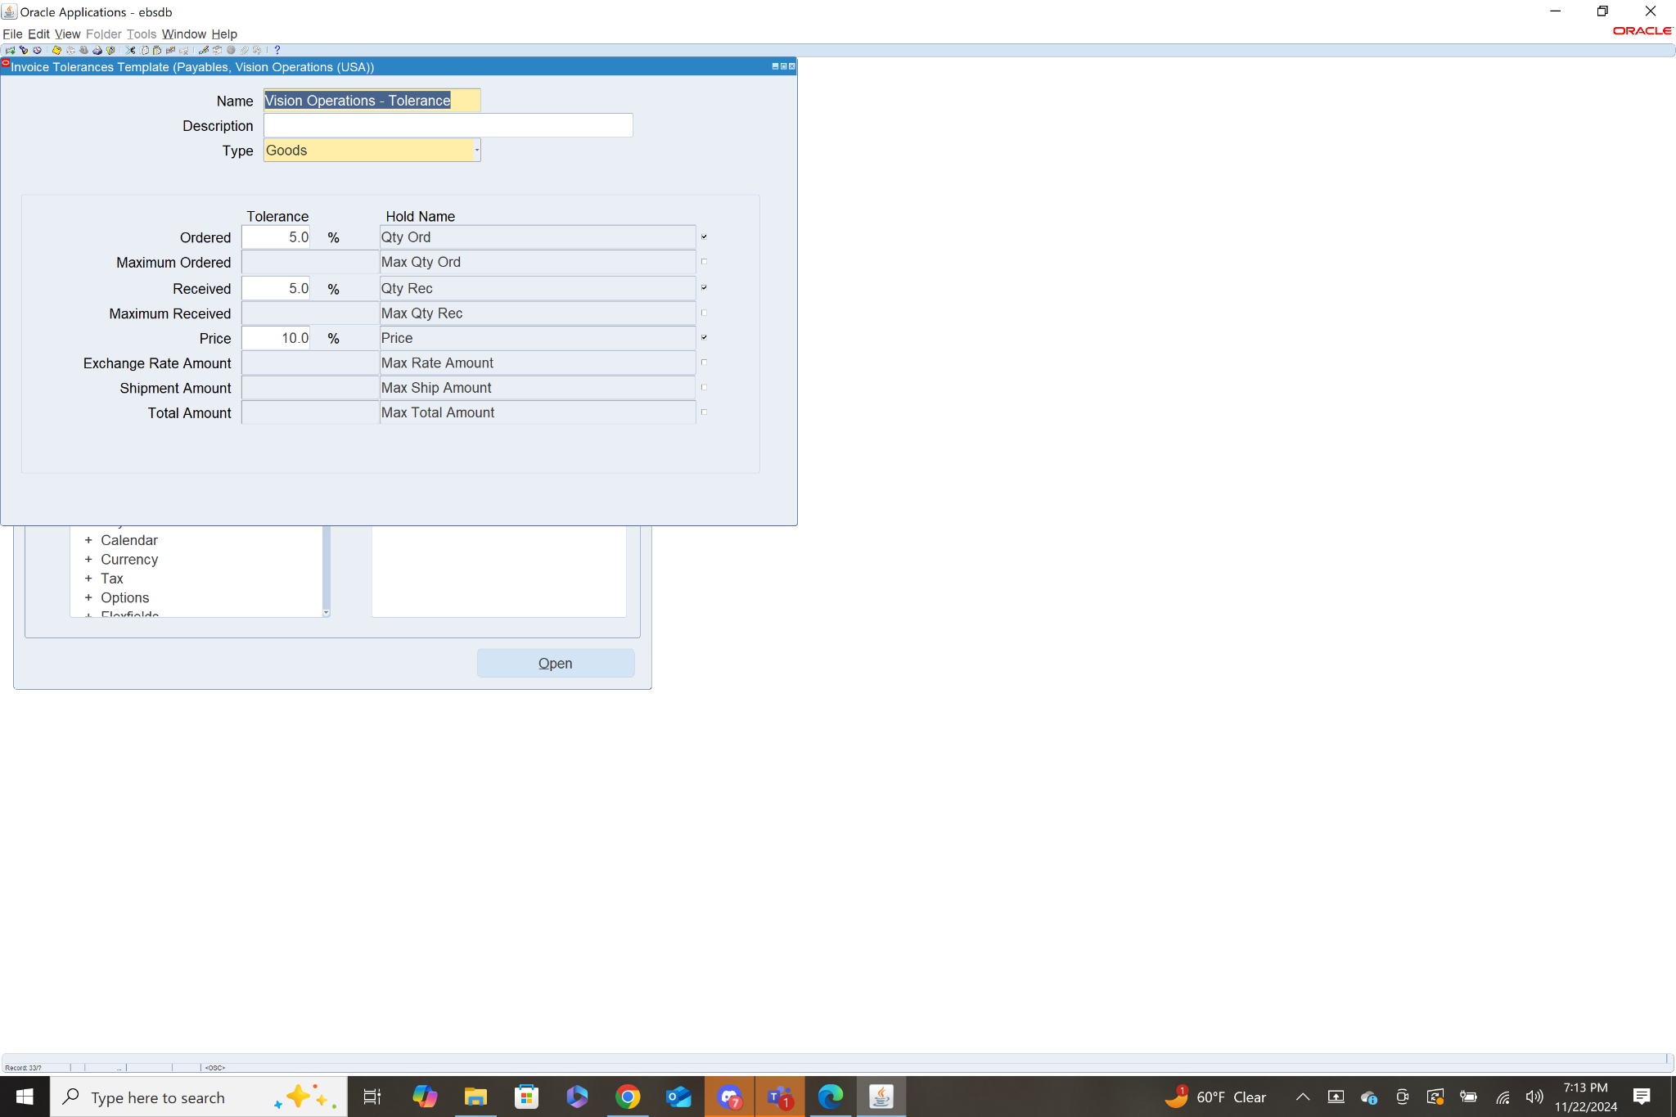

11.

* Requisition- Navigation: **Purchasing>Requisitions>Requisition**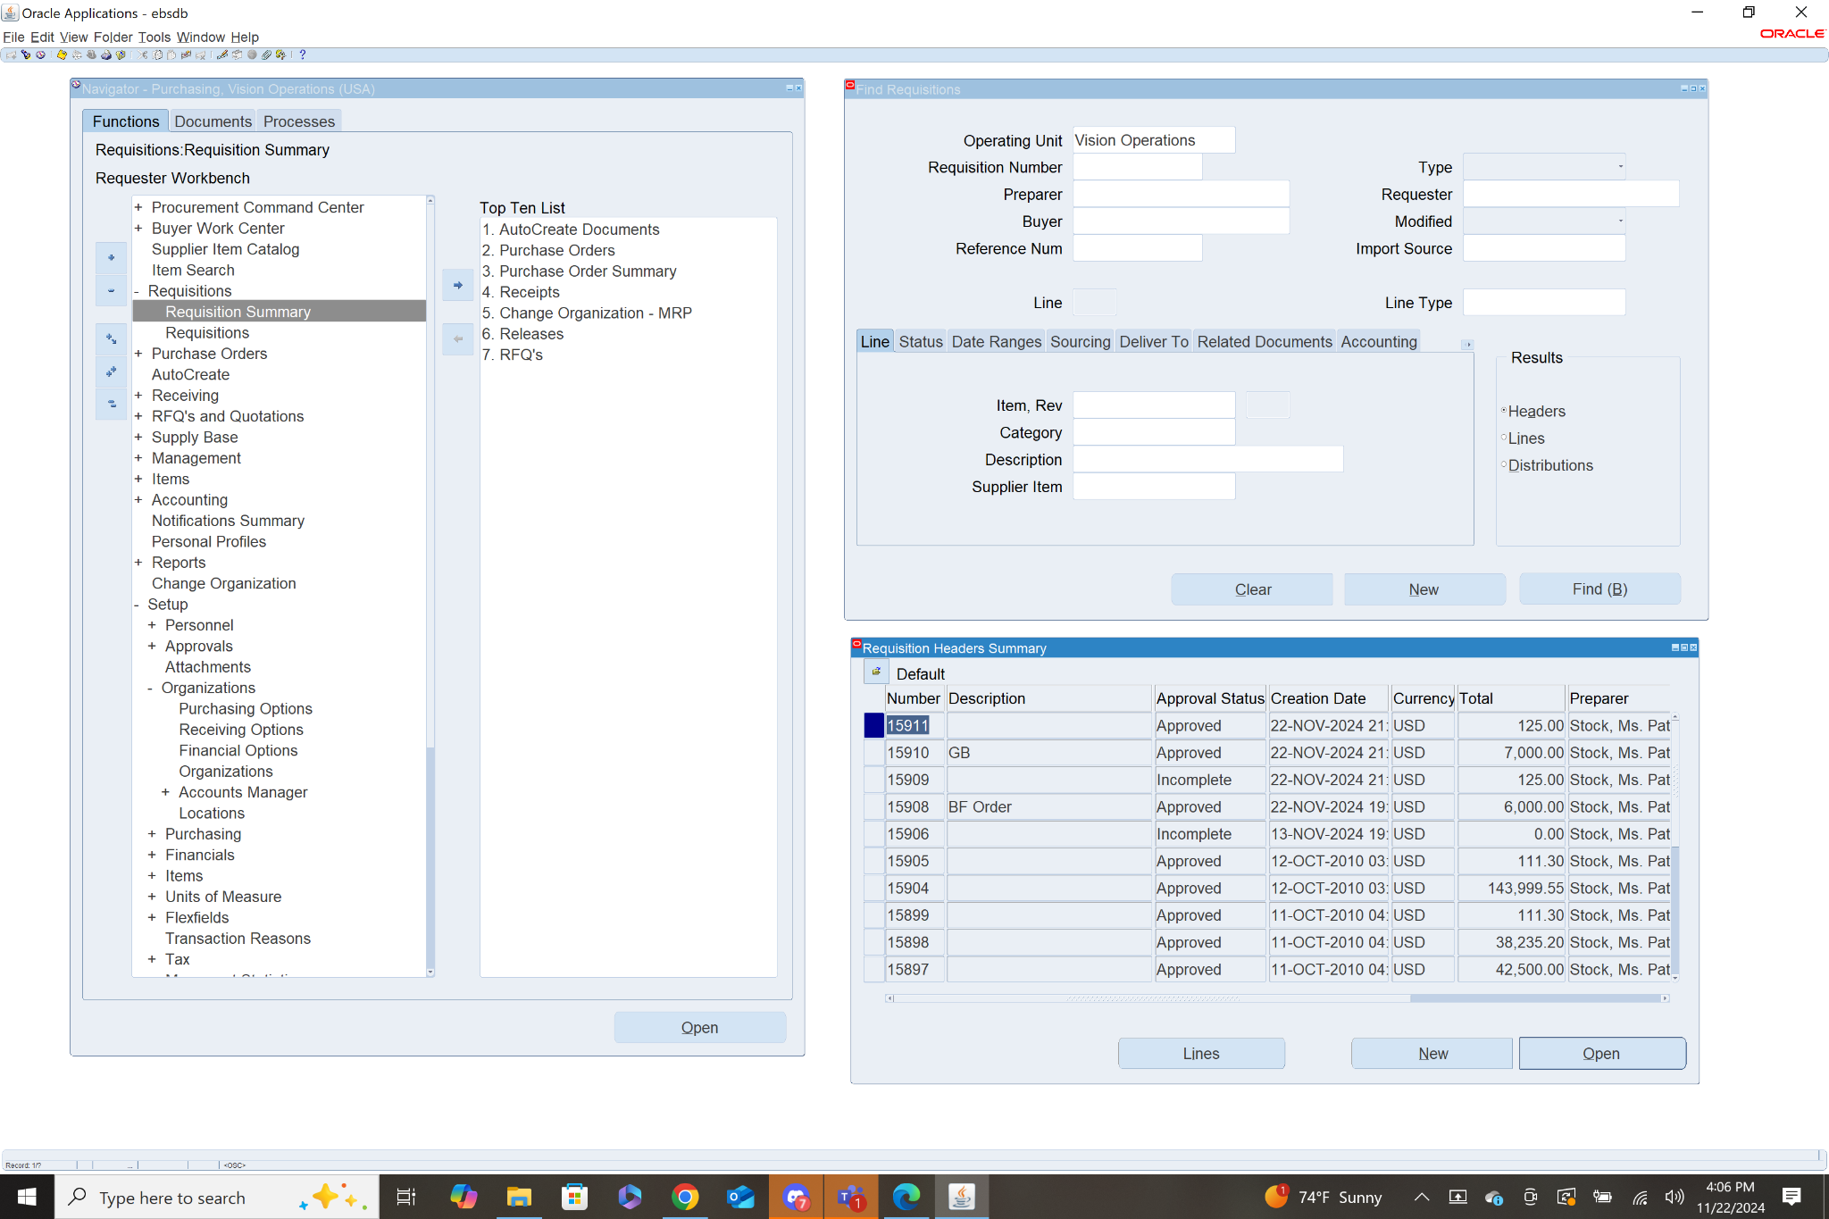
* Fill out specific criteria for which Requisitions you are looking for, I used Vision Operations for the Operating Unit. Click Find.



* A list of requisitions matching the given criteria is shown. Select one and click Open, I chose Number 15906



* Details are then shown for the given requisition. Key information includes, the list of items being requested with details on the Type of Item, Name of the Item, Category, Description, UOM, Quantity, Price, and when the item is needed. You can also view information about the source and currency.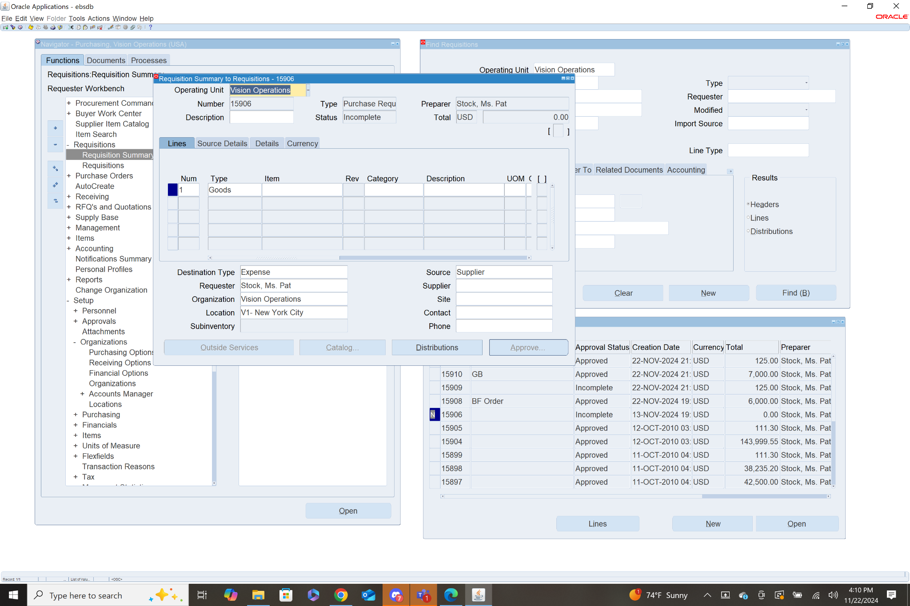
* Purchase Order- Navigation: **Purchasing>Purchase Orders>Purchase Order Summary**

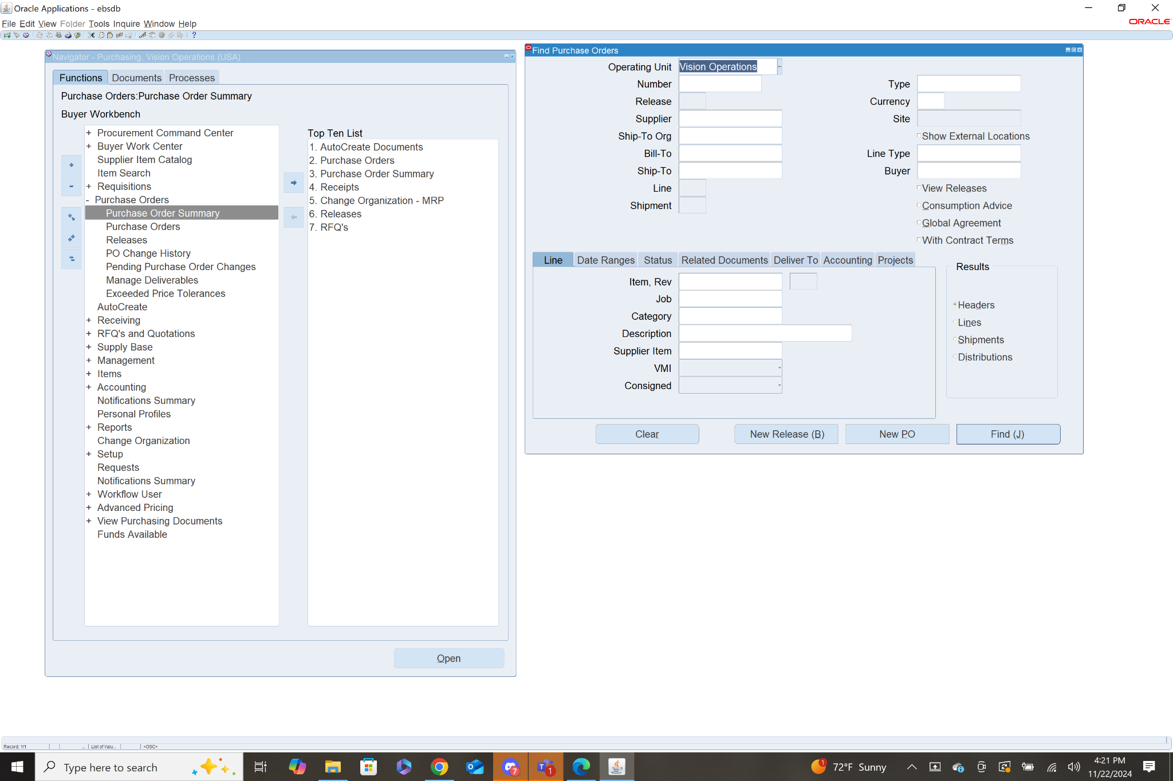

* Fill out specific criteria for which Purchase Order you are looking for, I used Vision Operations for the Operating Unit. Click Find.



* A list of purchase orders matching the given criteria is shown. Select one and click Open, I chose Number 6590

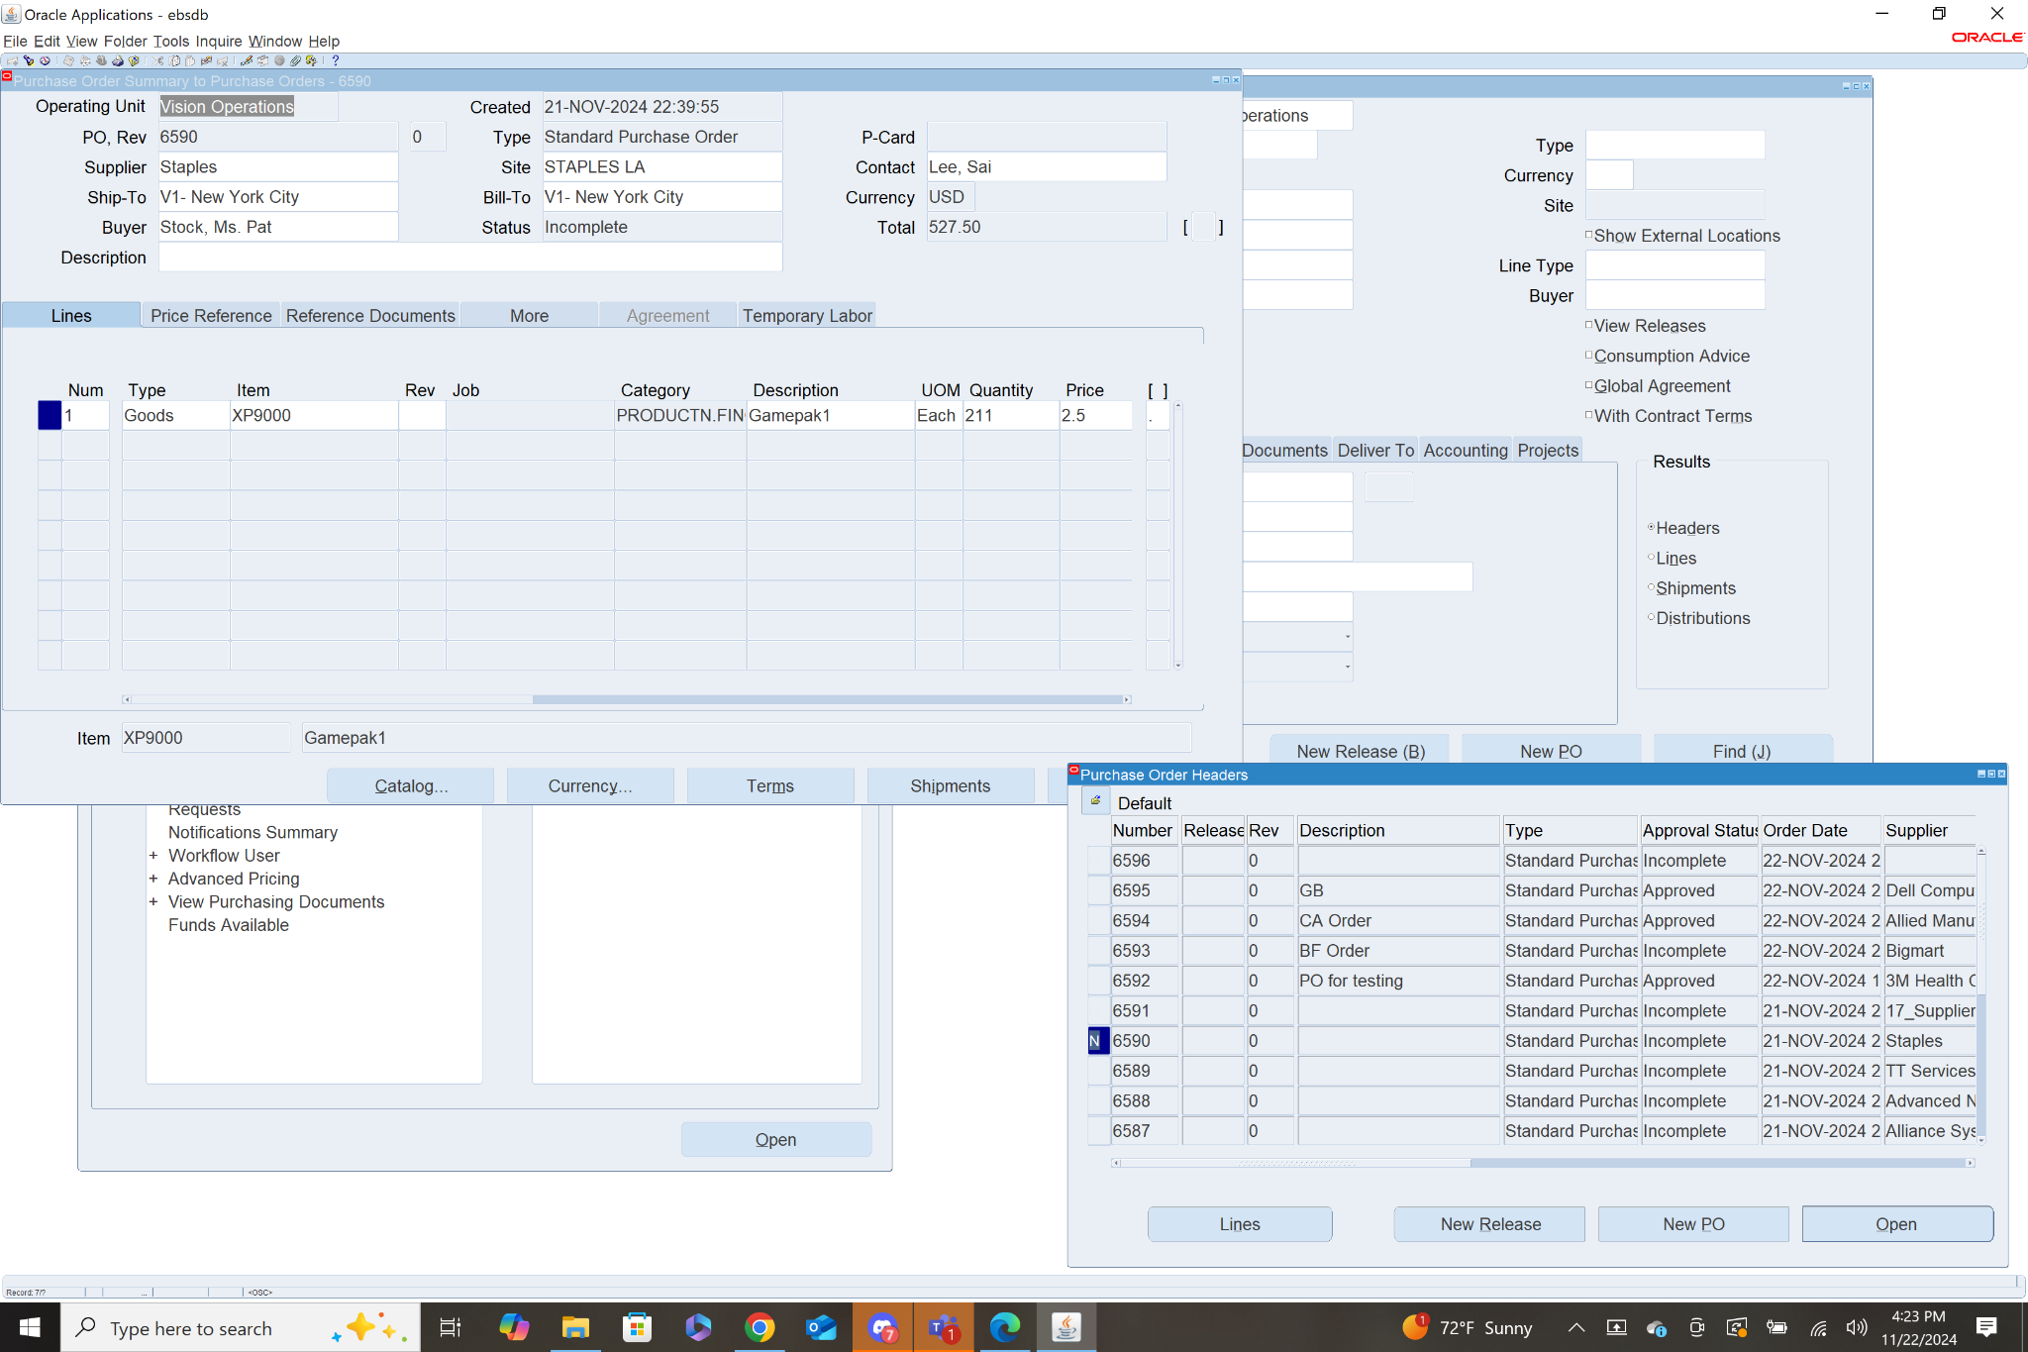

* Details are then shown for the given purchase order. Key information includes Date Created, PO Rev, Type, Supplier, Supplier Site, Contact, Ship-to, Bill-to, Currency, Buyer, Status, and total price. You can also view information about the list of items being purchased with details on the Type of Item, Name of the Item, Category, Description, UOM, Quantity, Price, and when the item is needed.

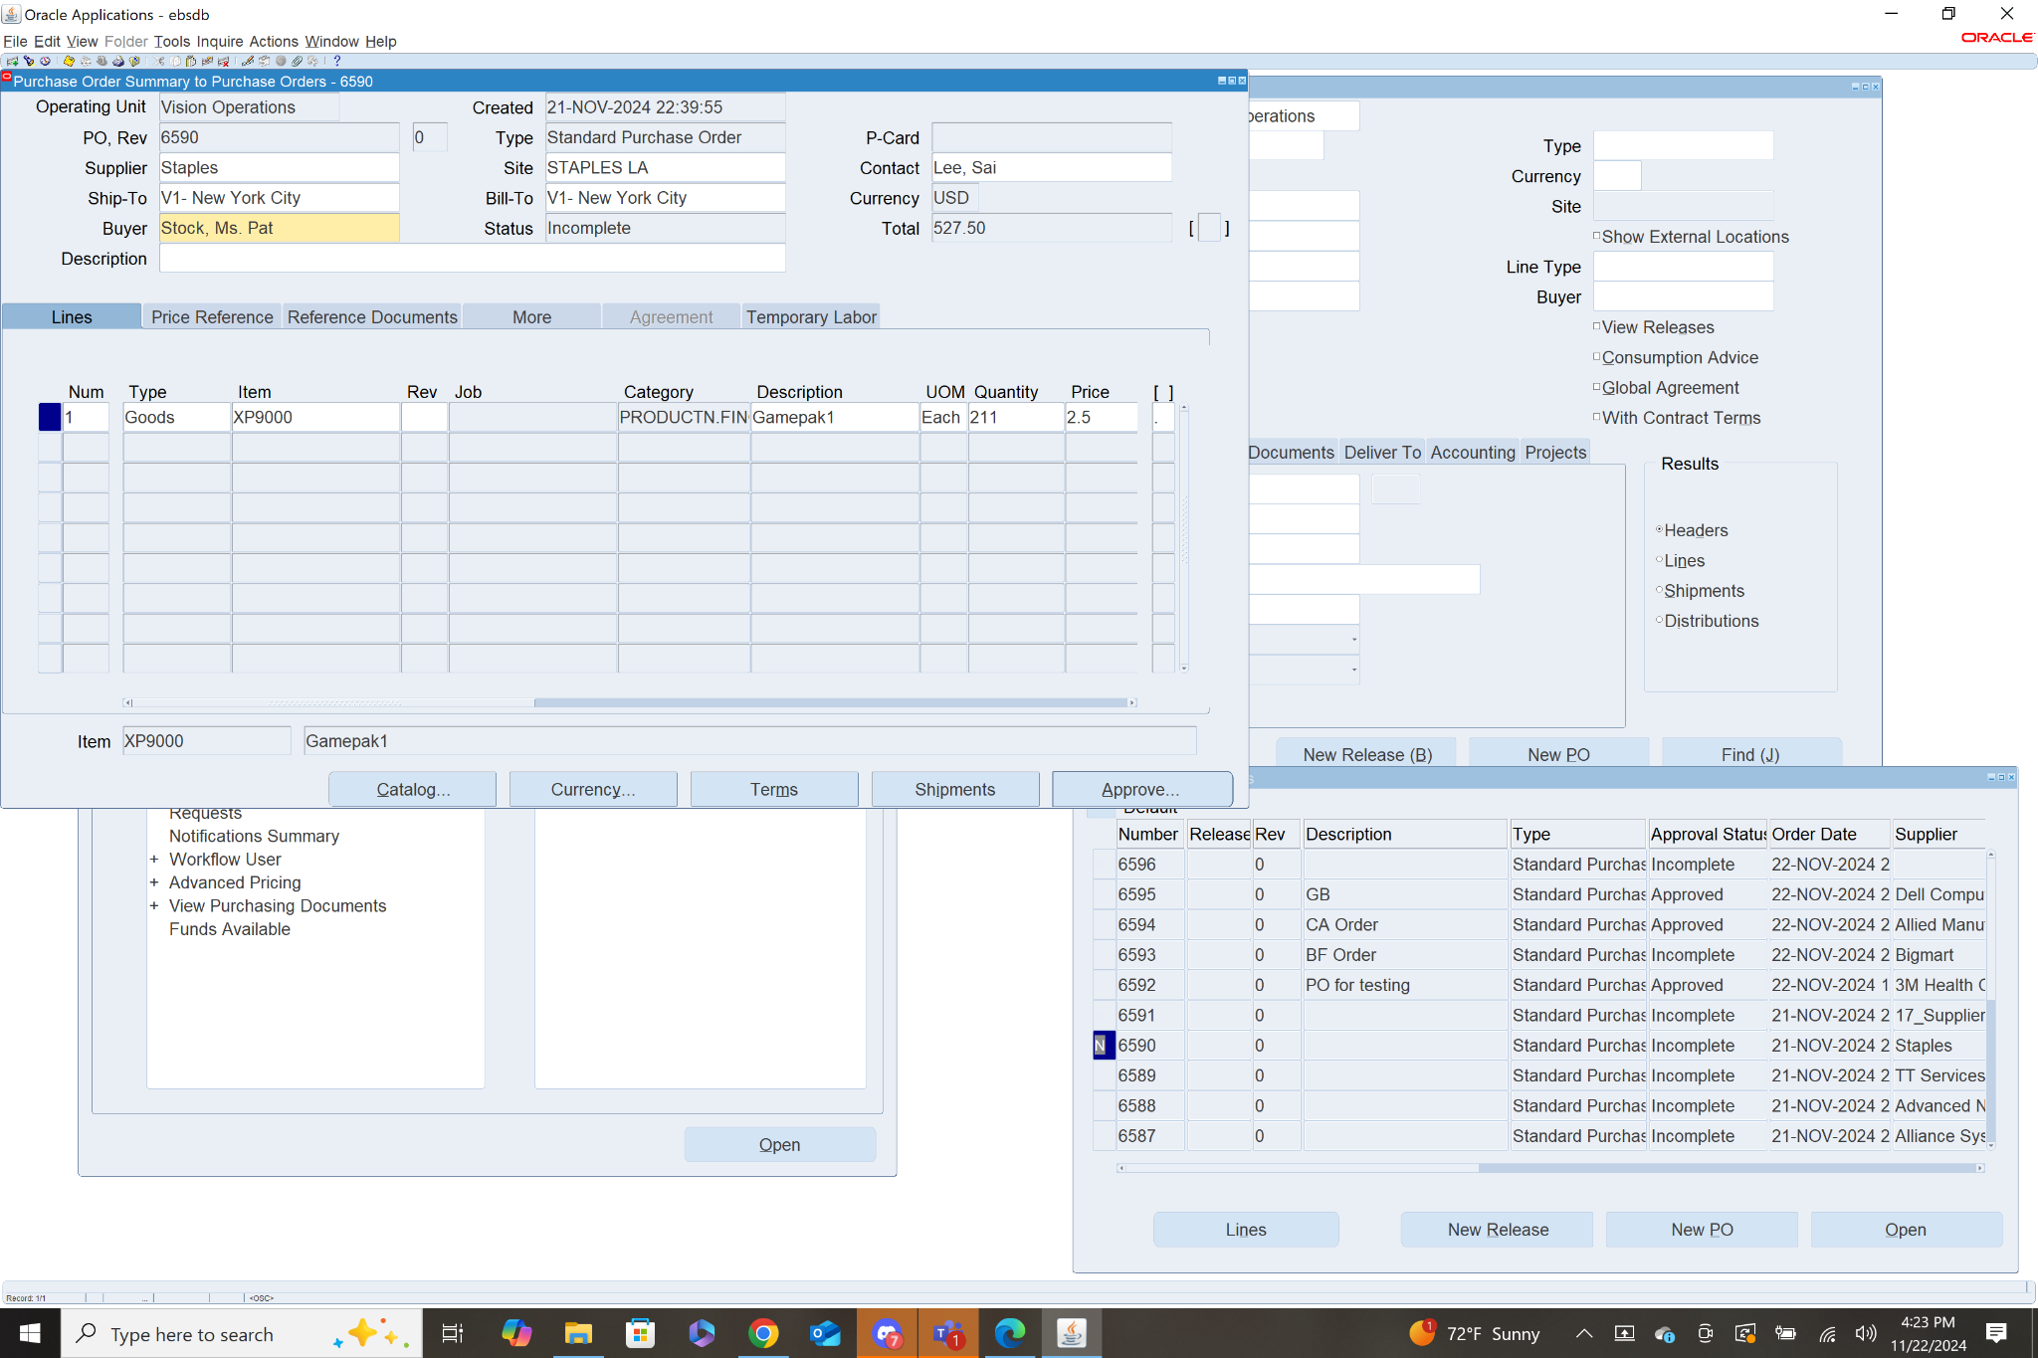

* Receipt for PO- Navigation: **Purchasing>Receiving>Receipts**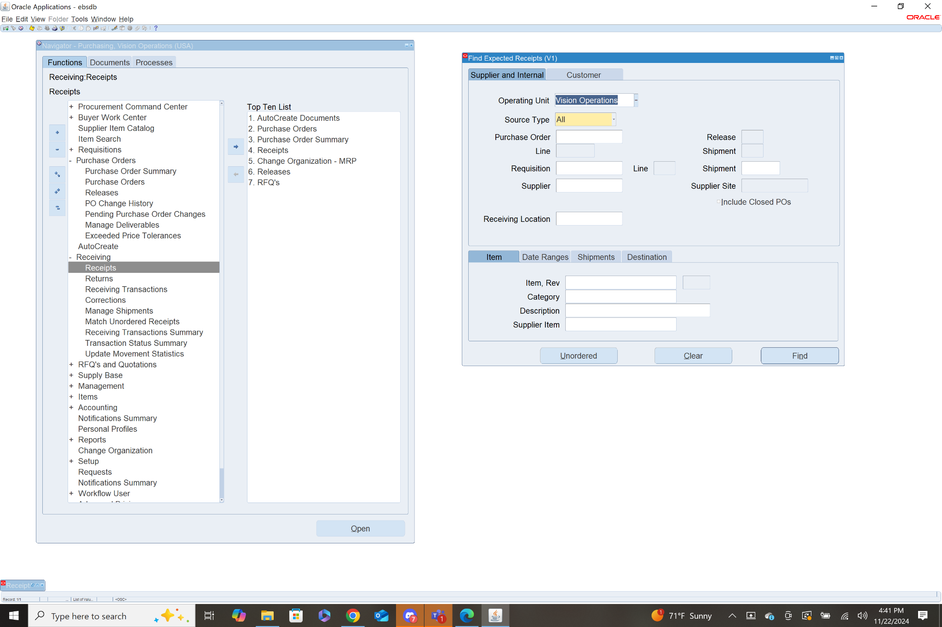
* Define Criteria for receipts searching for, I used Vision Operations as Operating Unit and Source Type All.



* A list of all receipts is shown from the oldest to the newest.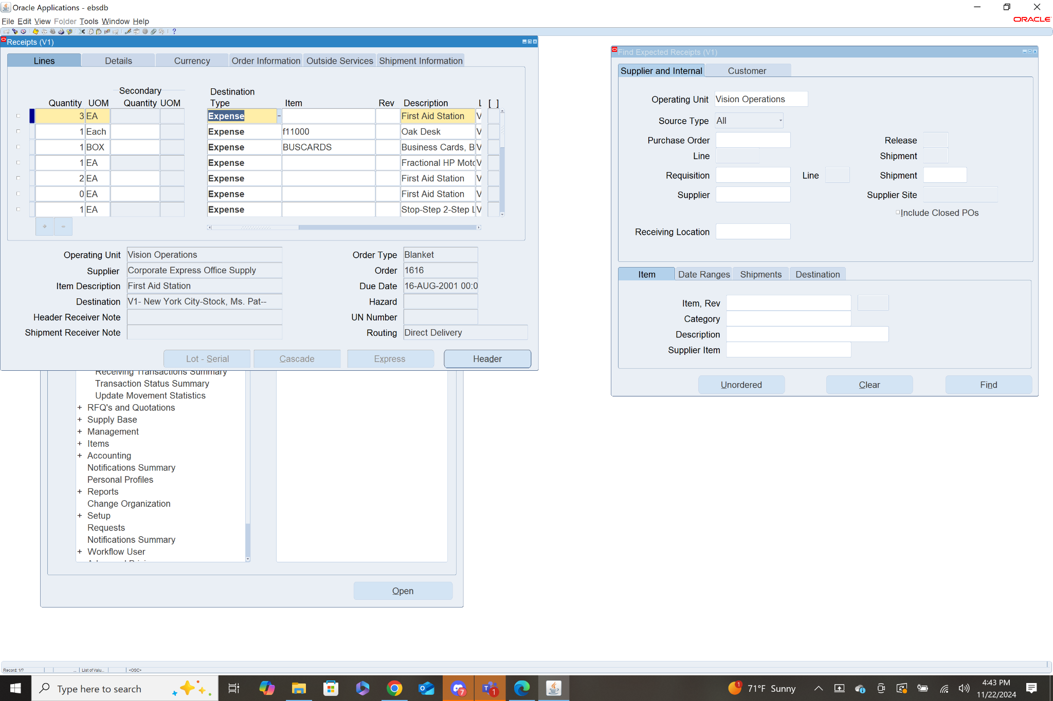
* There are several tabs with different pieces of information, shown below is the order information tab. The Order number shown is the Purchase Order number that it belongs to.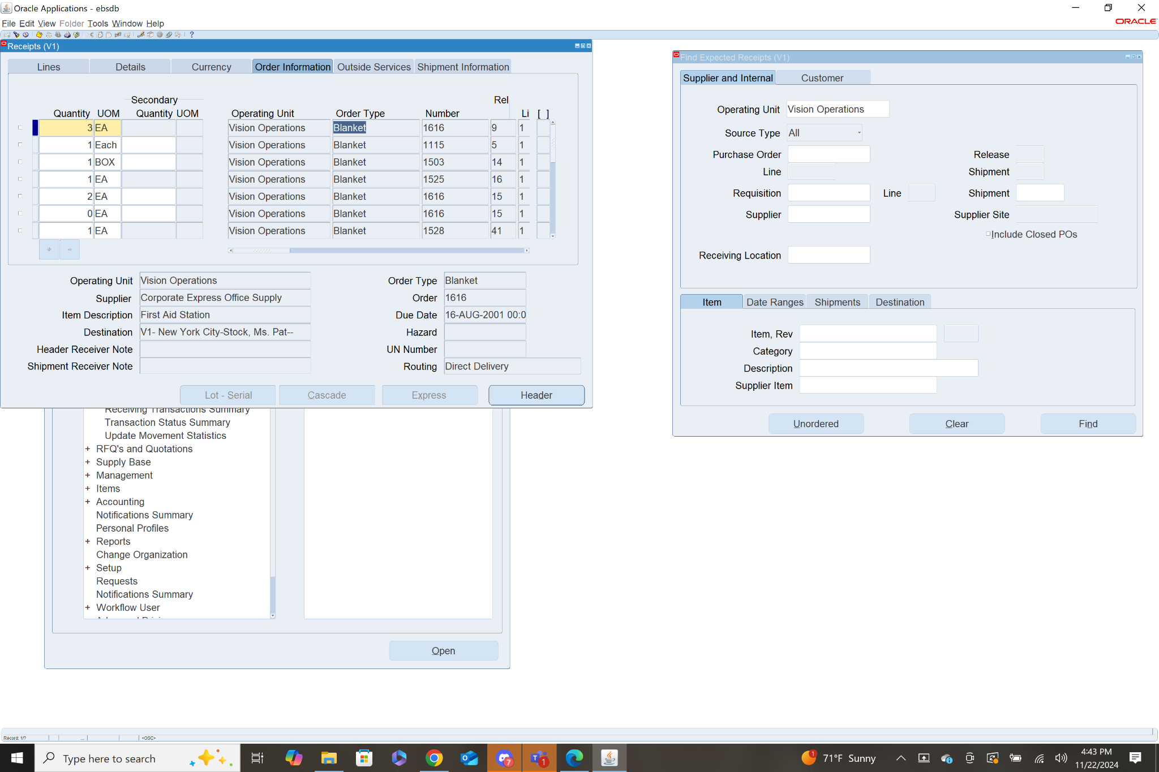

12-15. Steps to procure 5 desktop computers and 10 chairs.

* 13. Step One- Create Supplier
  + **Payables>Suppliers>Entry> Click Create Supplier**
  + Add organization name: “XX_CJW_Supplier”
  + Select Standard Supplier
  + Tax Country United States
  + Select Apply, then New Organization
  + Click address book top left then create.
  + Enter address information, check boxes for purchasing and payment.
  + Click Continue and then check box next to XX_CJW_Supplier and click save
  + Then click quick update link, accept default ship to and bill to location, click save

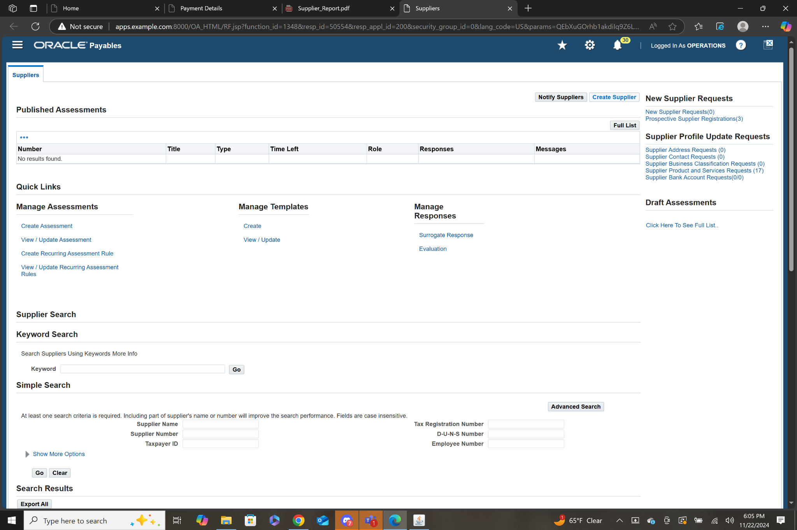

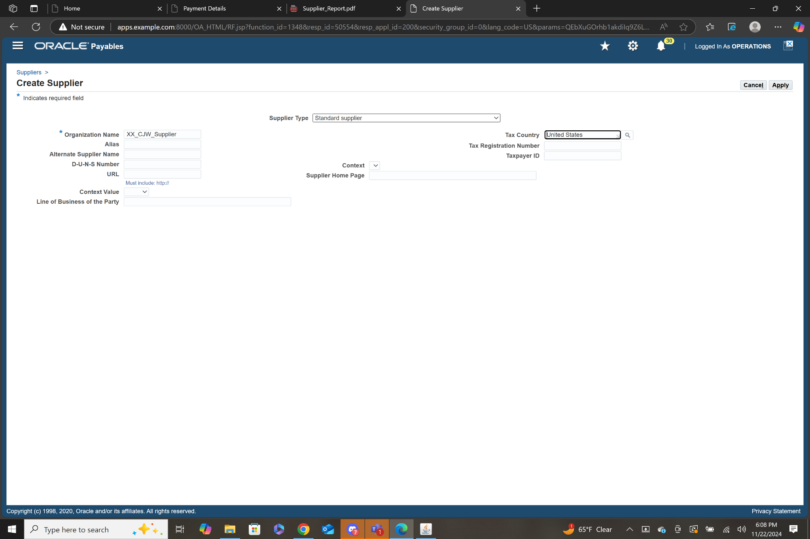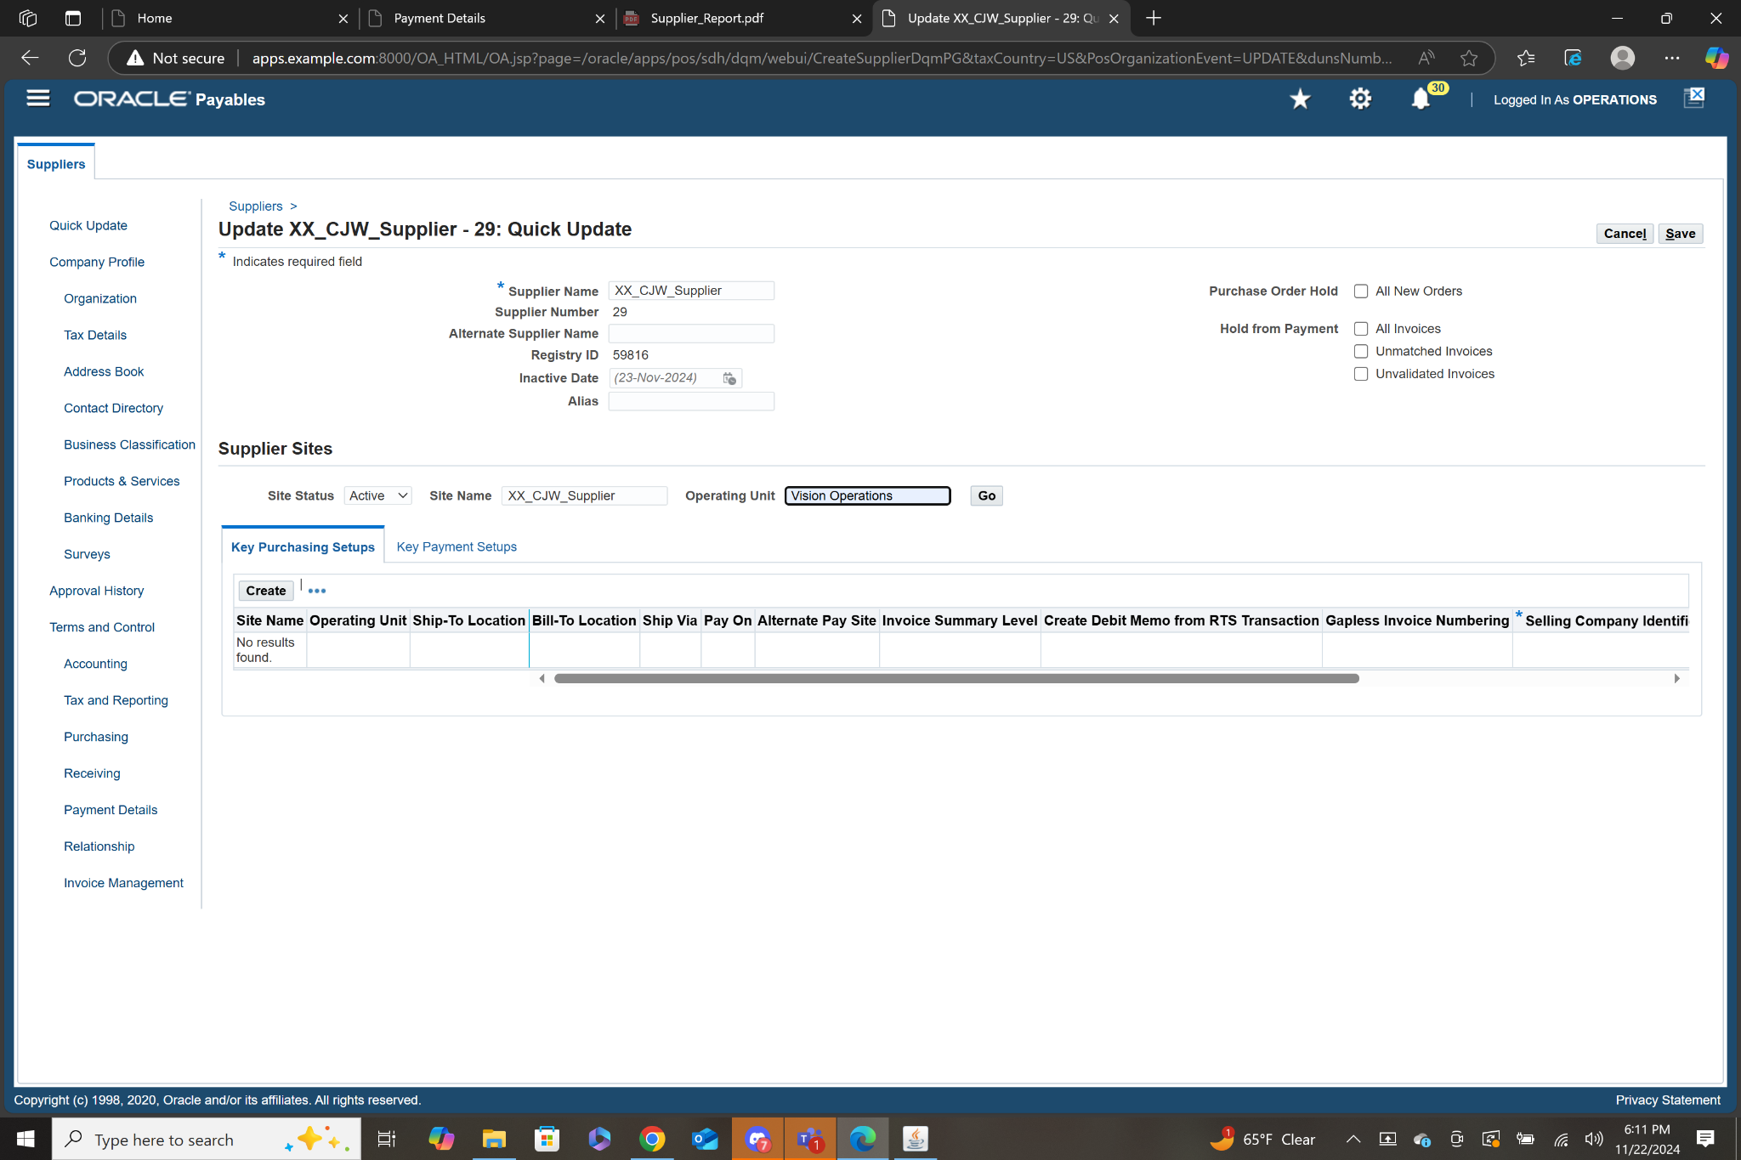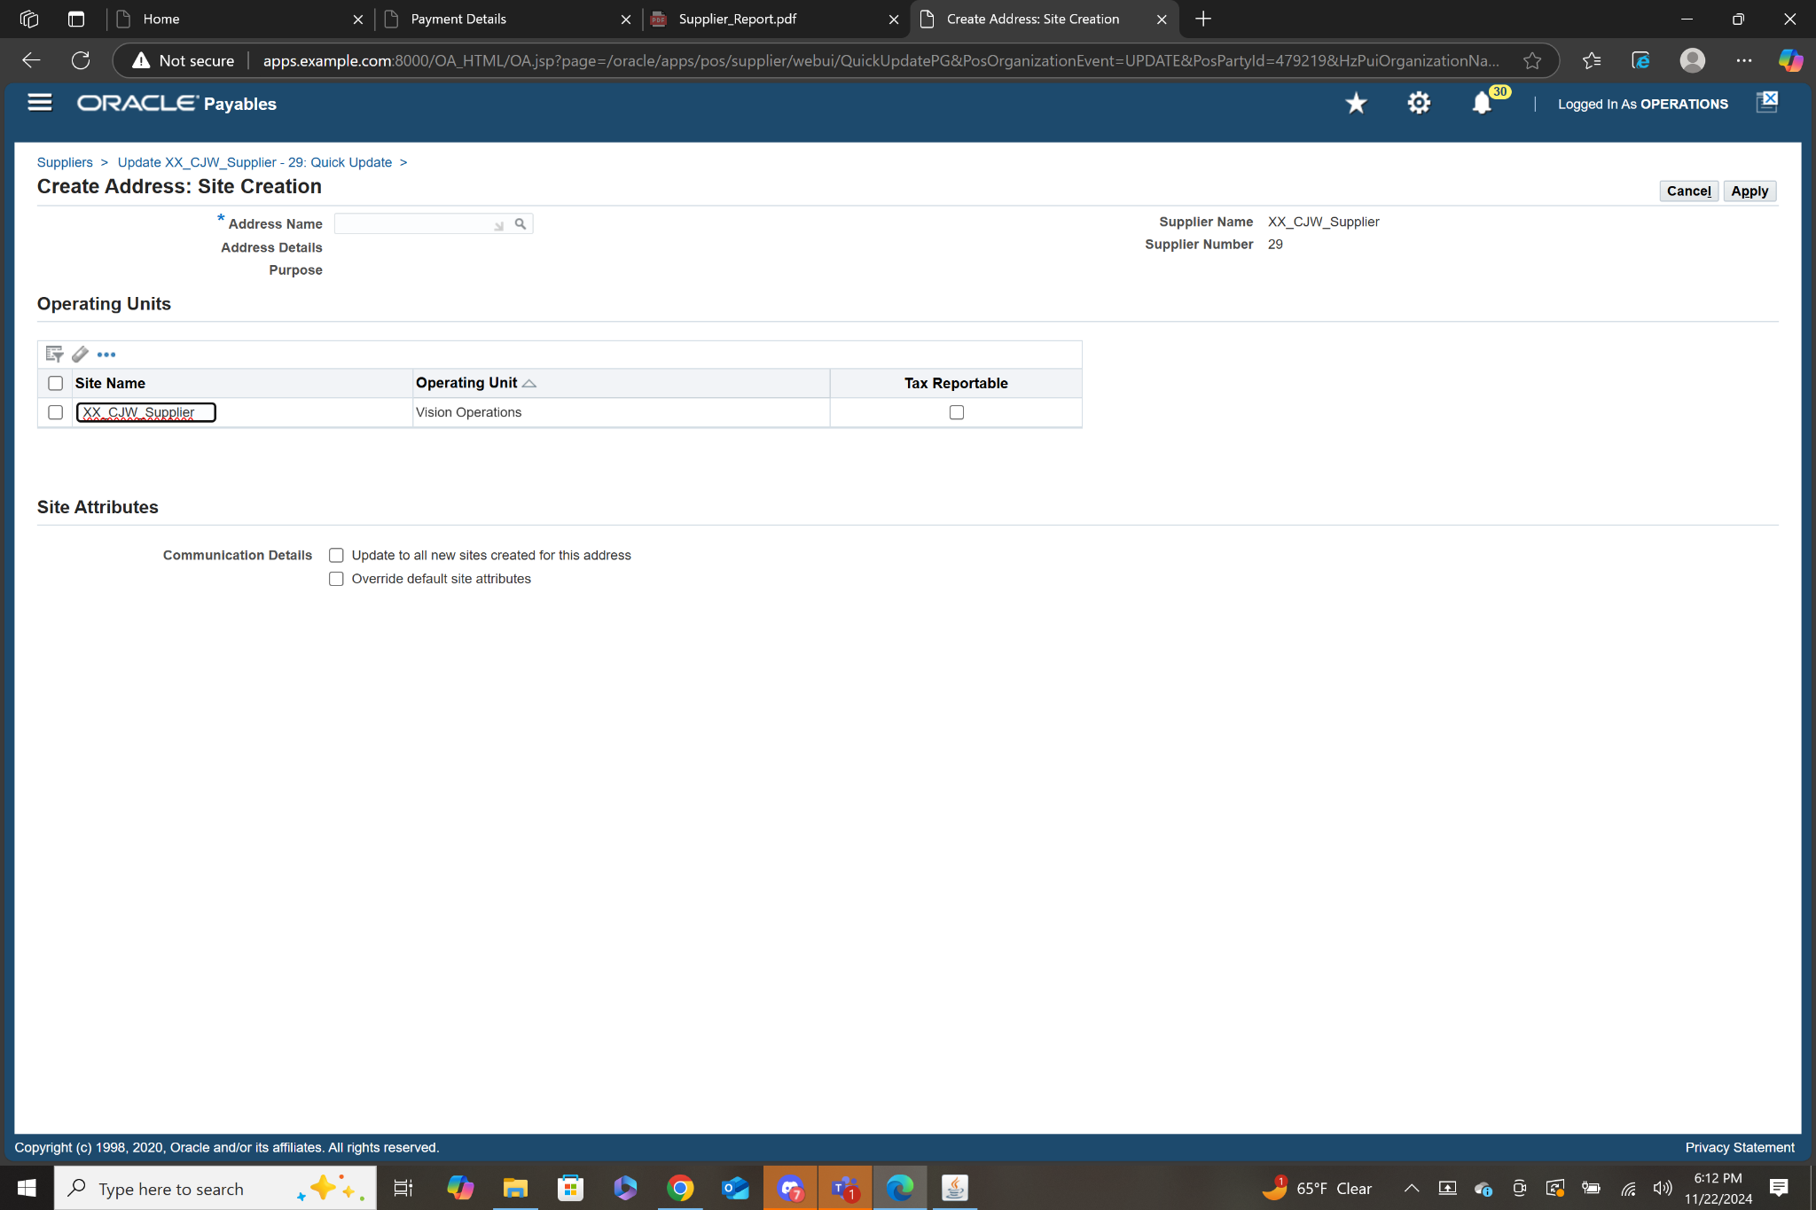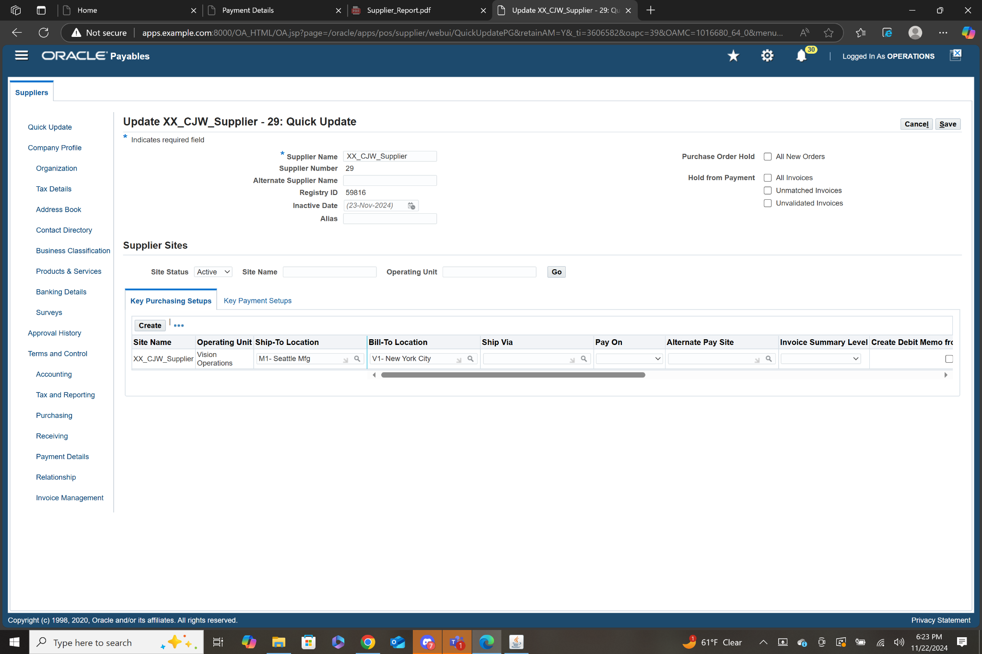

* 14. Step Two- Create Requisition
  + **Purchasing>Requisitions>Requisition Summary> Click New**
  + Select the first line in the lines table, Num and Type will be autofilled, Type as Goods.
  + Select Category, choose Computer Hardware from LOV and Desktop for Commodity.

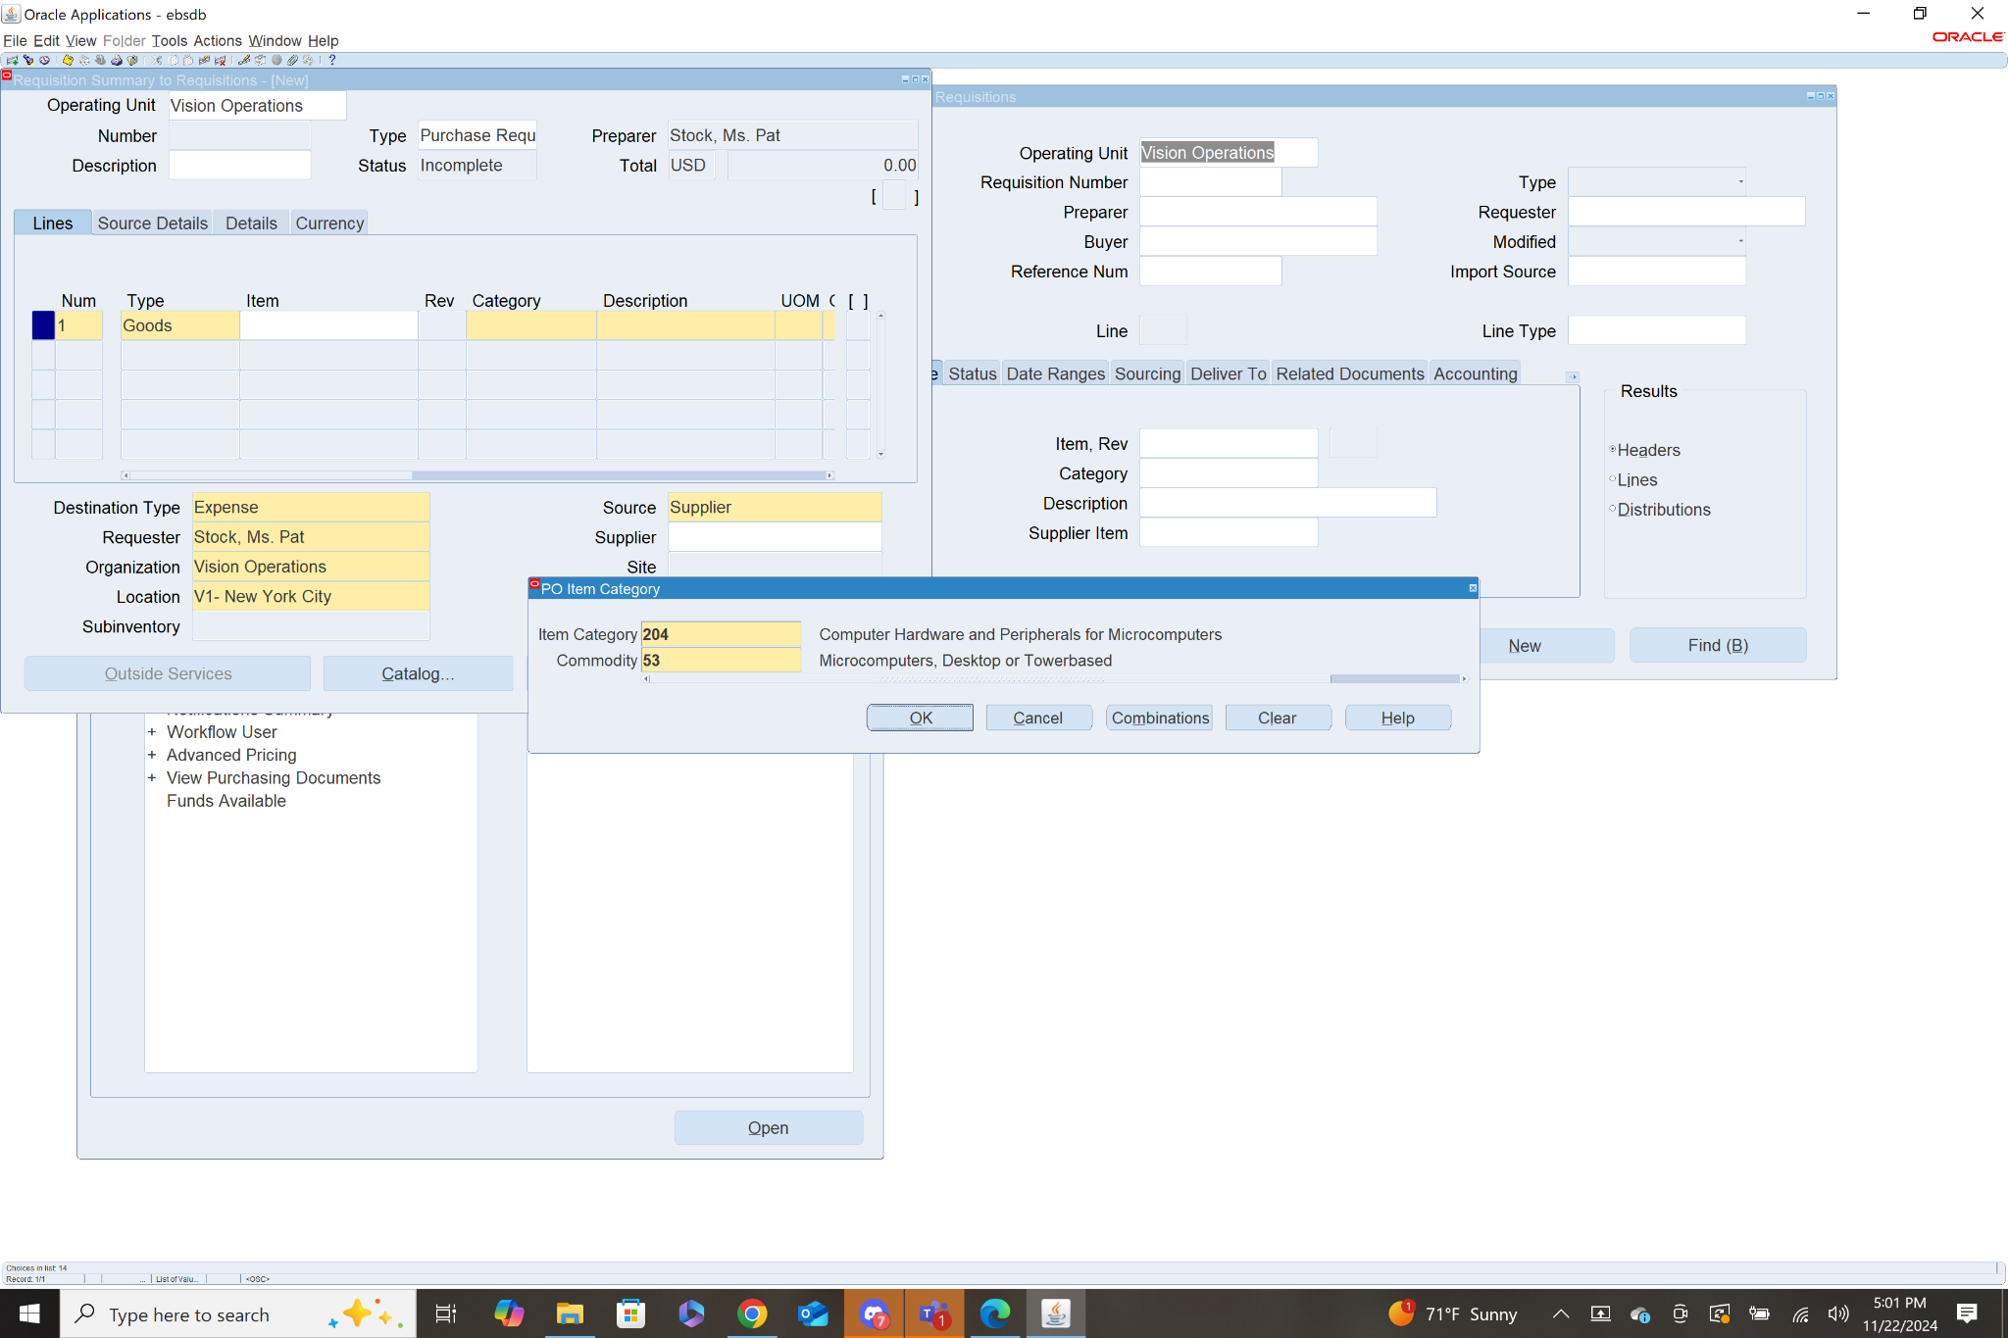

* + Enter a description: “XX_CJW_Req_Desktop”
  + Choose Each for UOM
  + Set quantity to 5
  + Price set to $500 each
  + Next Select Line 2 in the lines table
  + Select Category, choose Furniture: Office from LOV and Posture Chairs for Commodity.

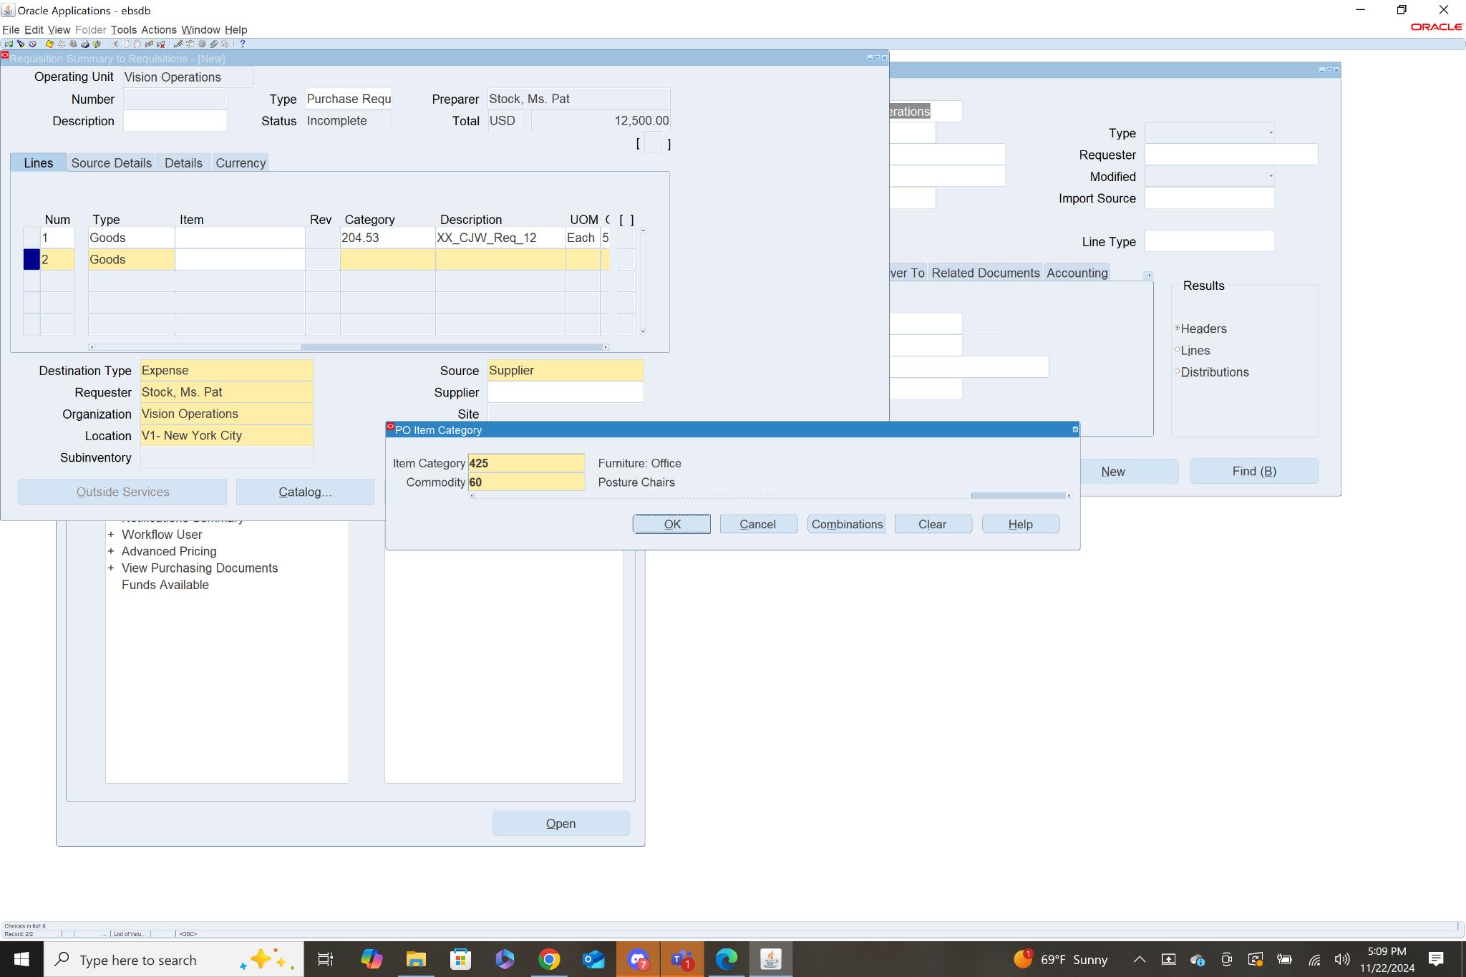

* + Enter description: “XX_CJW_Req_Chairs”
  + Choose Each for UOM
  + Set quantity to 10
  + Price set to $100 each.
  + Create Description for Requisition “XX_CJW_Req_12”
  + Save using yellow floppy disk icon at the top
  + Submit for approval by clicking approve then OK
  + Await Approval

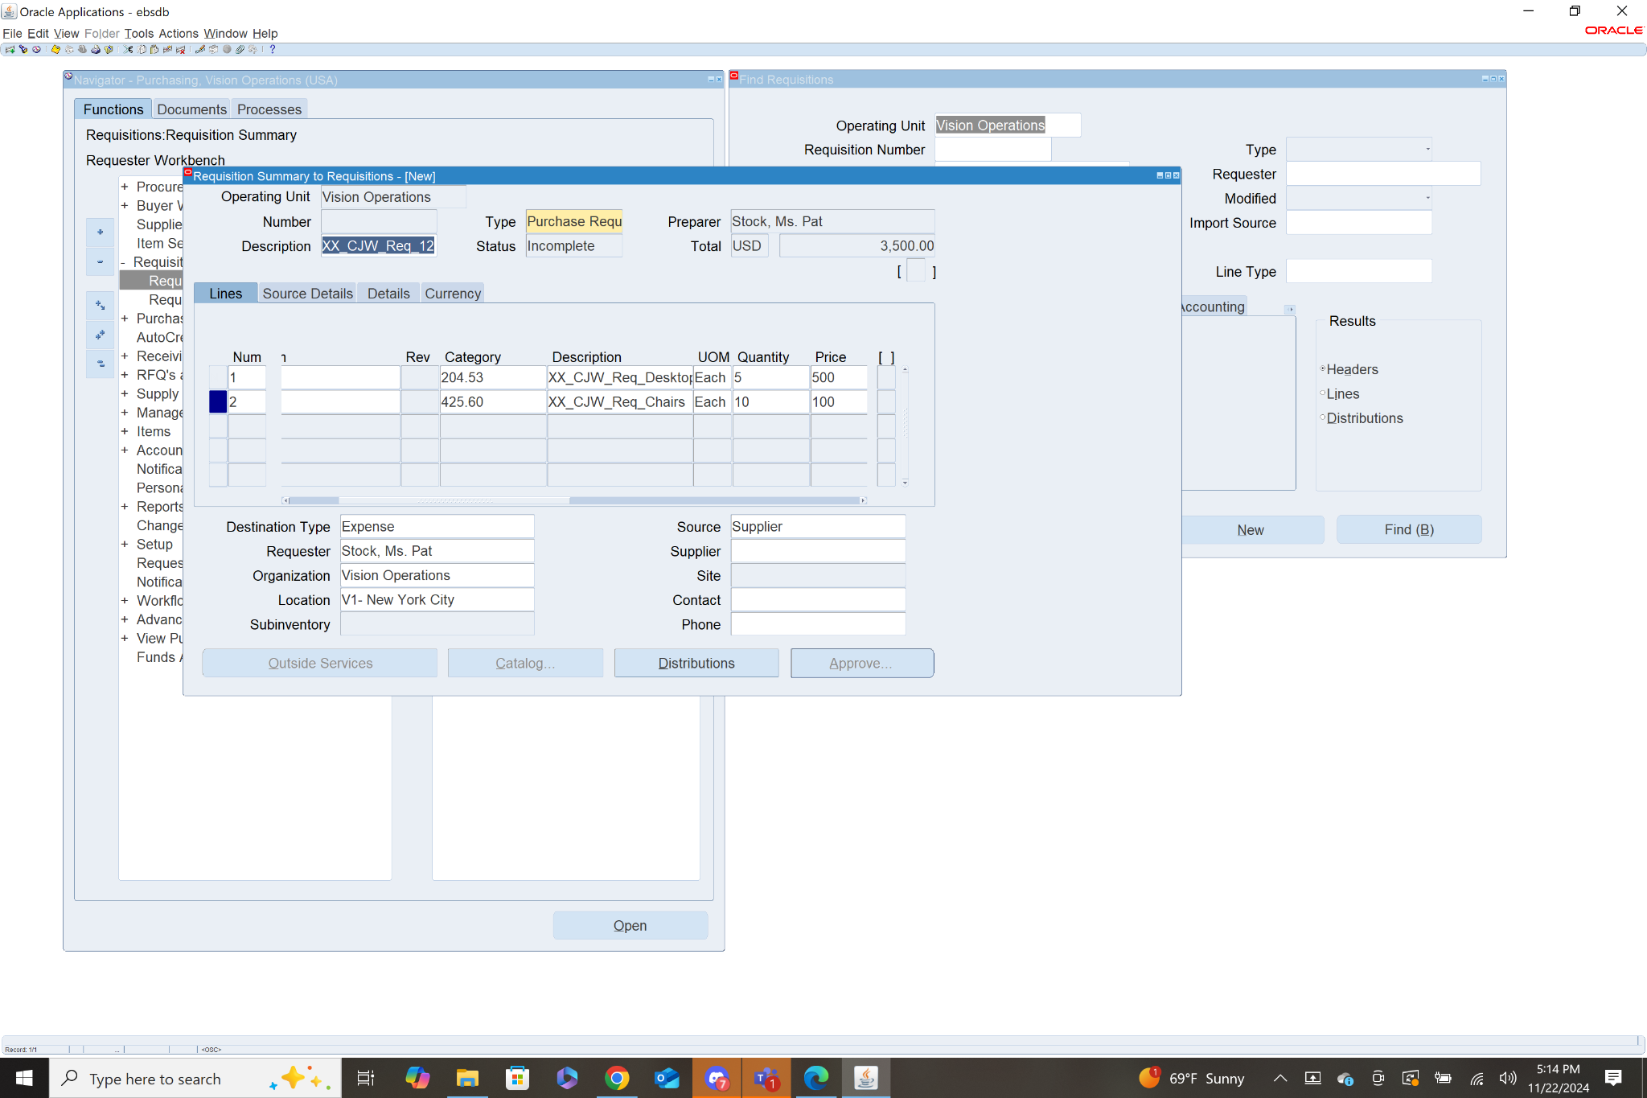

* 15. Step Three- Create Purchase Order
  + **Purchasing>Purchase Orders> Purchase Order Summary>Click New PO**
  + Some information is auto filled, you will need to add the necessary supplier, I choose the supplier I created in practice “XX_CJW_Supplier”.
  + Add a description, “XX_CJW_PO_12.15”
  + Next is to add both items with the exact same information used in the requisition during step one.

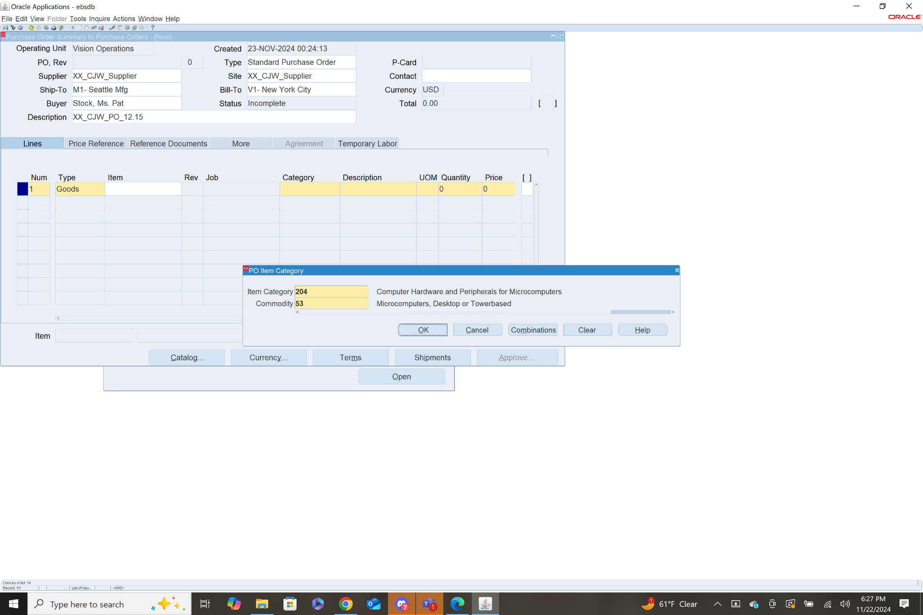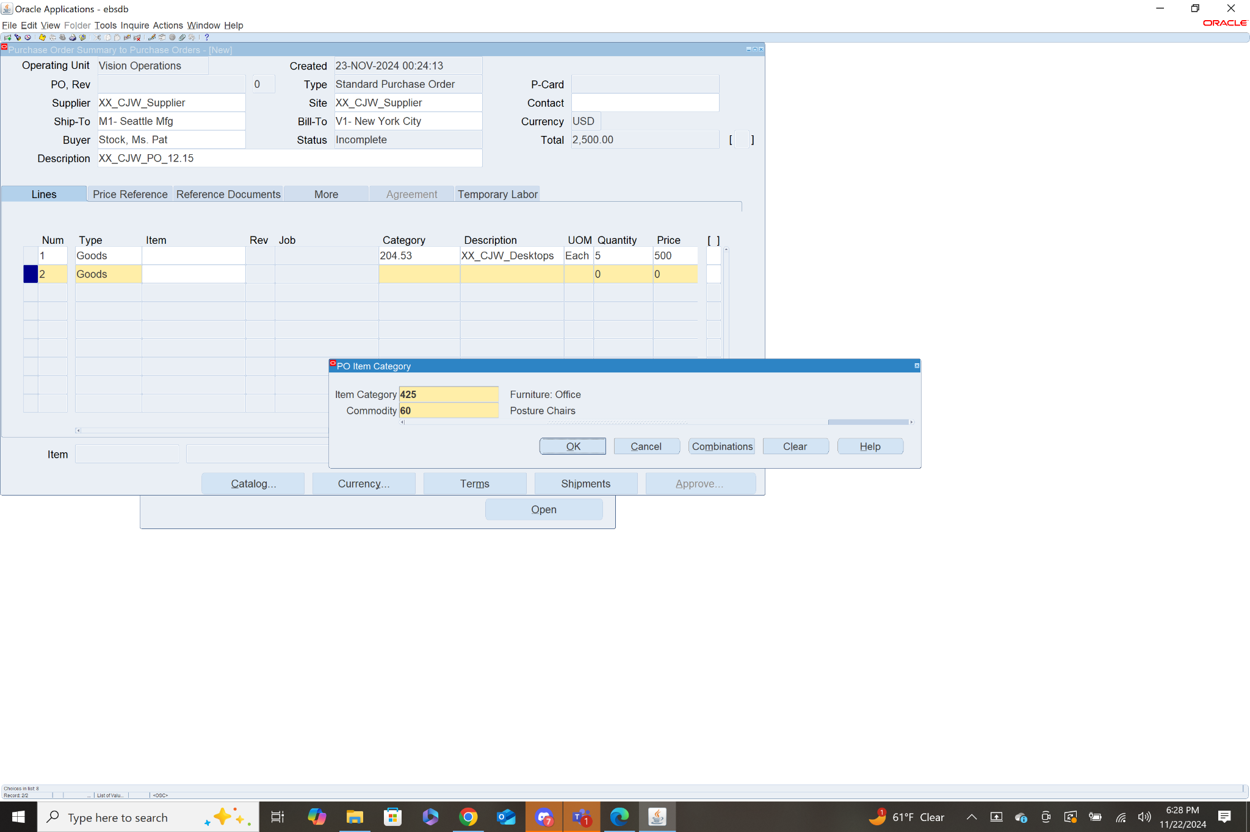

* + Save using yellow floppy disk icon
  + Submit for approval by clicking approve then OK
  + Await approval
  + Await arrival of Goods

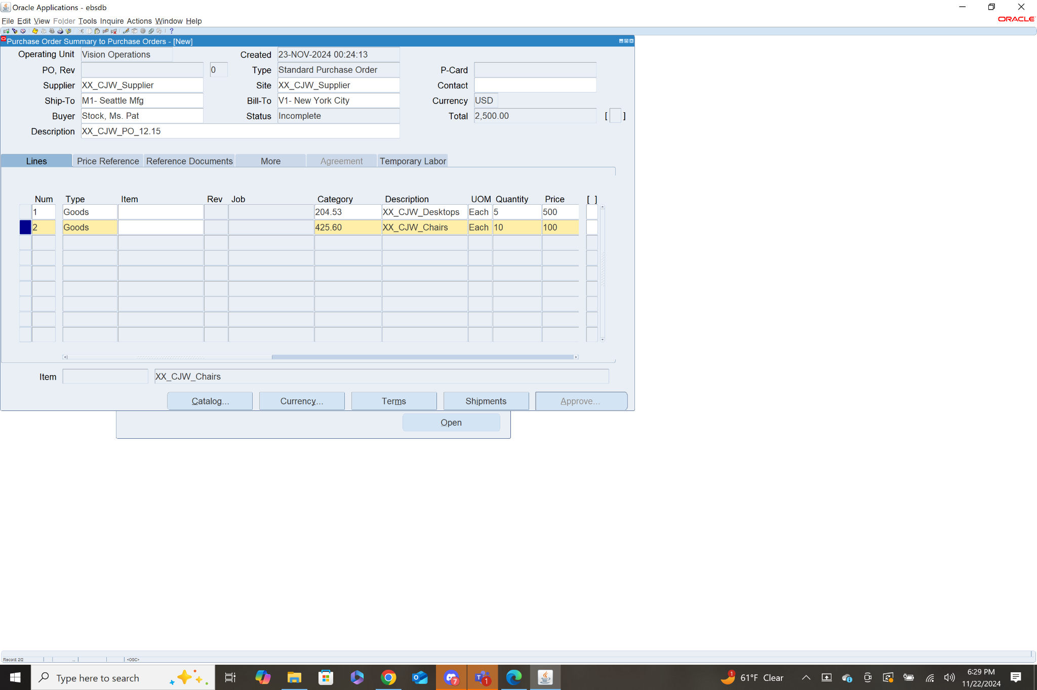

16. Navigation: **Purchasing>RFQs and Quotations>RFQs**

* Enter the type of RFQ, I chose Bid RFQ.
* Enter Due Date
* Select the first line in the lines table. Then enter the information for the item you need a quote for. I chose to run an RFQ for the desktop computers I used in the last question.
* Then save by clicking the yellow floppy disk icon.

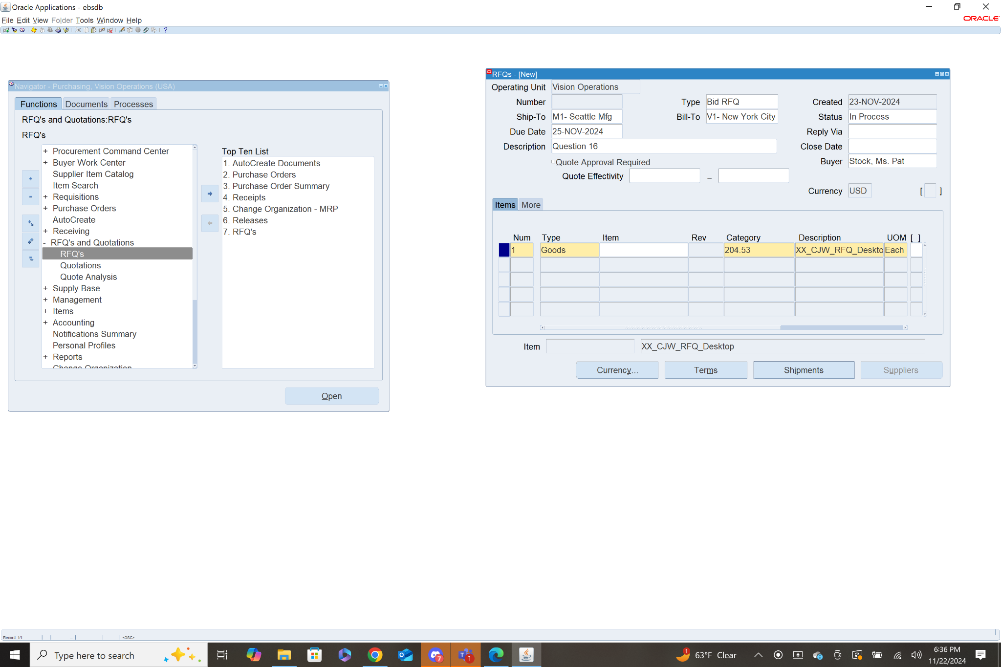

17.Navigation: **Purchasing>Setup>Organizations>Financial Options**

This brings you to a menu with a list of GL Accounts that are updated. The list includes: Liability, Prepayment, Bills payable, Discount Taken, PO Rate Variance Gain, PO Rate Variance Loss.

